5/15/2026

Finite Element Analysis of 3D Millipede Bar
To better understand the physics of the 3D millipede bar, finite element analysis simulations were created using Abaqus software. We desired to compare experimental results with those from simulation for two lengths of straight rectangular prism strikers: the 18cm (~7in) “short striker” and 76cm (~30in) “long striker”. Furthermore, a simulation was required wherein a 3D millipede bar at half-scale is used as the striker, providing insight for our future apparatus goals and the strain pulses expected from such a striker.
{Note: this paragraph will probably need to be moved to the experimental setup section.} Using Split-Hopkinson Pressure Bar (SHPB) theory, the short striker’s is made to be half as long as one side of the millipede bar, resulting in a pulse with equal length as one side (36cm). The long striker was meant to be half of the millipede bar’s full acoustic length, i.e., one side length multiplied by five total rods, divided by two. This way, the pulse would be the same size as the millipede bar’s full acoustic length, mimicking the full acoustic length of a millipede bar striker at half-scale. However, with a millipede bar side length of 36cm, this required a striker length of 36cm × 5/2 = 90cm, which posed a manufacturing difficulty in keeping the rectangular prism’s orthogonality. Avoiding zero curving was not possible, and the 90cm length exceeded the milling machine’s clamp reach. For a pulse to reach through at least 4 rods requires a length of at least 36cm × 4/2 = 72cm; a striker length between 72cm and 90cm was deemed suitable for testing. A long striker of 76cm provided a sufficient compromise for our research purposes.
Modeling the short and long straight strikers was a simple matter of creating rectangular prisms of the same dimensions as in experiment: 12mm×24mm×180mm for the short striker, 12mm×24mm×760mm for the long striker. The 3D millipede bar was also modeled against the real-world specimen, with the same 12mm×24mm rectangular cross section for the first rod, and 12mm×12mm square cross section for each ensuing rod. The side length matched 360mm as in experiment. Rather than being flush, the free ends of the millipede bar extrude 6mm further for contact with a striker, also included in the Abaqus model.
Partitions were created in the model, measuring 5mm×10mm, representing the strain gages and their placements at the midpoint of each rod in the experimental setup. Strain measurements would eventually be extracted from these regions after complete simulations. Fig. 1 illustrates the 3D millipede bar Abaqus model and partitions for the strain gages, as well as the naming convention matching each numbered rod. Rods 1 through 5 correspond with Gages 1 through 5.
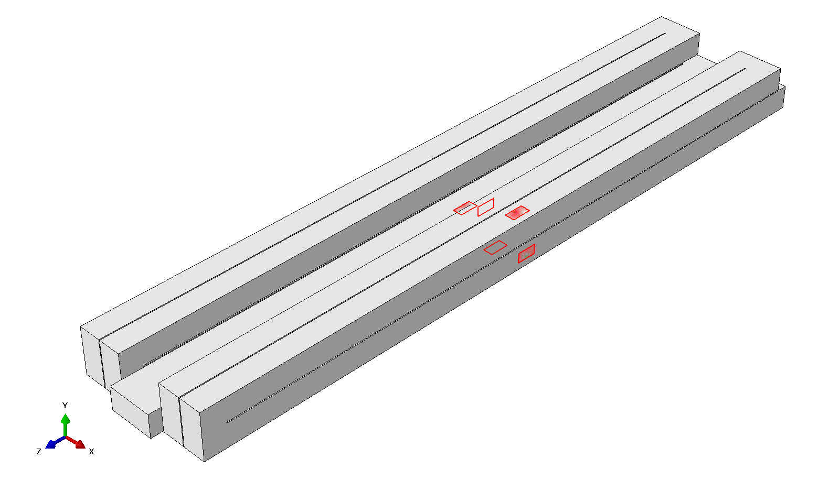
Gage3
(inner)
Gage1
Gage2
(underneath)
Gage4
Gage5
Fig. 1. Millipede bar modeled in Abaqus with strain gage locations and naming convention.
Gaps between segments were set to 0.5mm = 500micron, although this was in error. The specimen’s gaps were in fact 720micron apart. This did not significantly alter quality of simulation results, seen later with comparison to experiment. At the end of the gaps, fillets were added onto the model for realistic, circular end cuts formed from either CNC or wire EDM machining. Fillet radius was set to 250micron, forming a semicircle at the end of each gap (Fig. 2).
(a) 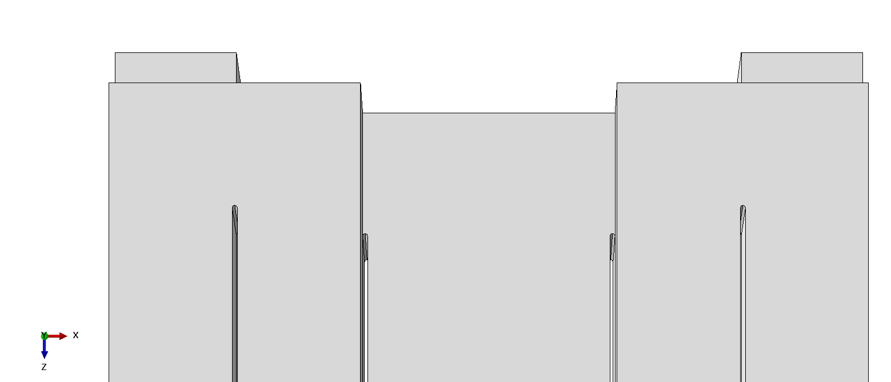
(b) 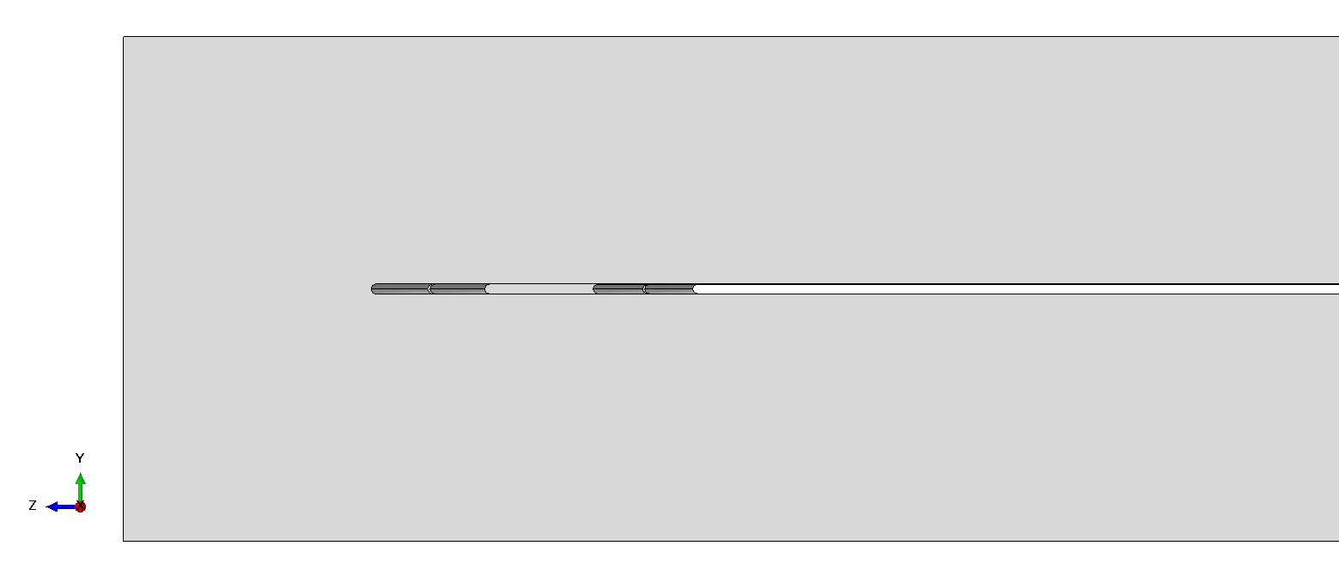
Fig. 2. Fillets at the ends of gaps between rod segments, (a) vertical view and (b) horizontal view.
The millipede bar specimens and striker bars were constructed out of 6061-T6 aluminum. Relevant mechanical properties were selected with modulus of elasticity E = 68.9GPa, Poisson’s ratio ν = 0.33, and density ρ = 2700kg/m³ [1]. The longitudinal wavespeed used in later calculations is calculated from uniaxial stress: C_{L} = $\sqrt{E /ρ}$ ≈ 5,051m/s [2].

With boundary conditions

Constraint Regions
In all simulations, the striker was placed flush against the input end of the millipede bar such that no simulation time is wasted waiting for rigid body motion calculations as the striker approaches the incident bar. Surface-to-surface contact was established between striker and incident faces, along with a predefined velocity set onto the whole body of the striker. This was successful in establishing immediate contact upon impact, then afterwards ensuring free ends, i.e., no contact between the striker and incident bars after initial impact. All strikers were allowed motion only in the axial direction, consistent with real-world motion of ideal launch.
Boundary conditions mimicking the brackets from experiment were implemented ensuring no rotation or translation in the undesired transverse directions. Fig. 3 shows the boundary condition regions shaded in, 40mm across and flush with the edges of the millipede bar’s junctions. Note that the inner sides of the millipede bar were constrained at each end for an idealized result.
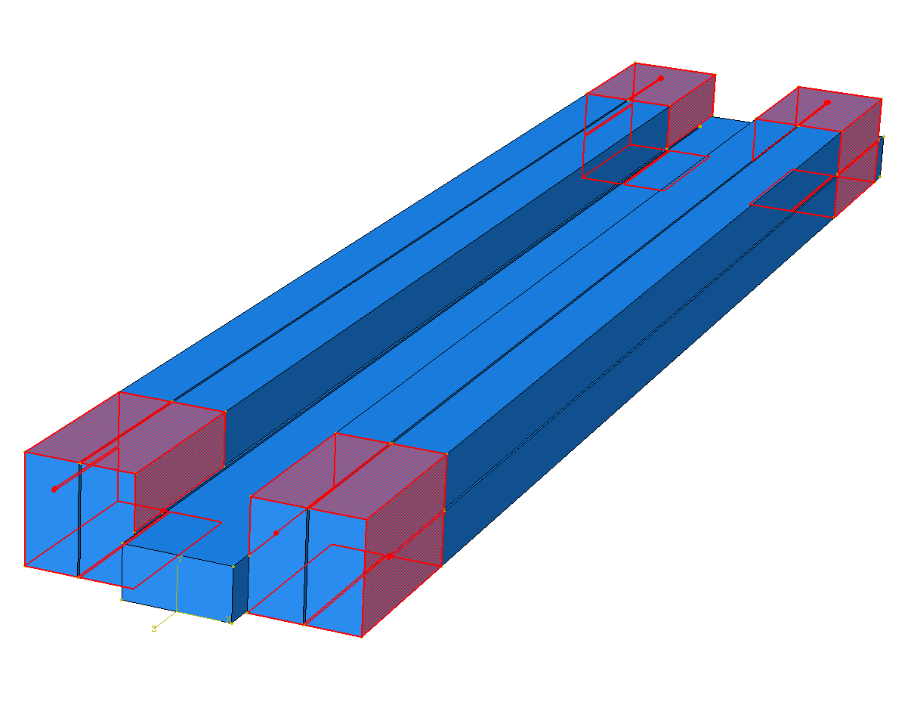
Fig. 3. Boundary conditions constraining translation in X and Y directions and constraining rotation in the X, Y, and Z directions.

Short striker, 18cm (7in)

Mesh & incrementation details (short striker)
With equal cross-sectional area, a striker bar of 18cm provides a pulse length of 36cm. Using a wavespeed of 5,051m/s for 6061-T6 aluminum under uniaxial SHPB conditions, the pulse duration is 360mm / (5,051m/s) ≈ 71.3μs. To capture five subsequent pulses—one from each rod of the millipede bar— a window of at least 5×71.3μs ≈ 356μs is required. Thus, a period of 400μs was used, along with a stable time increment of 2×10⁻⁹ s, collecting data at 200 equal intervals.
To create the FEA mesh on the millipede bar, nodes were created approximately 2mm apart from each other. Accommodating the curvature of the fillets, 8 elements per circle were used such that the semicircular fillet sections had at least 4 divisions. Quadratic tetrahedral elements were used to account for the thin junctions between gaps. These criteria generated 504,690 total elements with 765,353 total nodes for the millipede bar.
The striker bar did not necessitate a mesh as granular. For the rectangular face, an element size of 3mm was used, and along the length of the striker, an element size of 18mm was used, creating a 4×8×10 element volume, using linear hexahedral elements. These criteria generated 500 total elements with 726 total nodes for the short striker. Impact velocity was set to 2m/s.
Fig. 4 displays the assembly with meshes for this simulation. Simulations to follow utilized even finer meshes; consequentially, the higher order of elements decreases print quality and creates highly illegible images. Mesh quality may not be discernable from figures alone.
Henceforth, the four bend junctions between the millipede bar’s five rods will be added to the naming convention. “Bend1” refers to the junction between Rod1 and Rod2, “Bend2” between Rod2 and Rod3, “Bend3” between Rod3 and Rod4, and finally “Bend4” between Rod4 and Rod5.
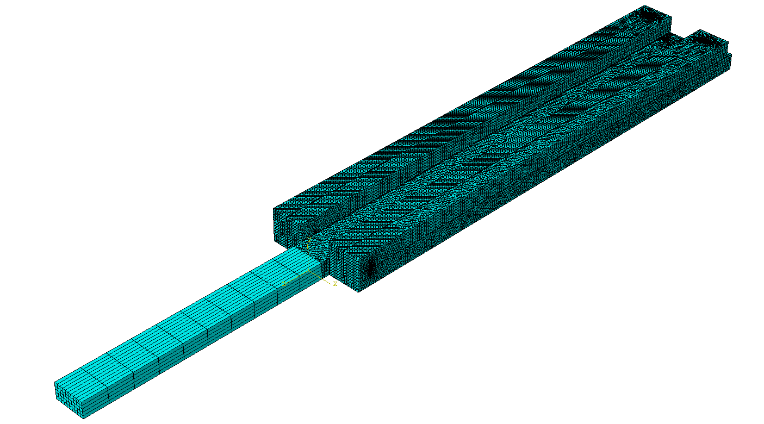
Fig. 4. Assembly of short striker and millipede bar with associated meshes.

Contour plot (short striker)
[Object 1 – Animation: millipede bar axial stress, short striker with boundary conditions]
The animation provided in Object 1 shows the pulse from the short striker traveling through all 5 rods of the millipede bar via measurement of axial stress, S33, with isometric and underside views. From SHPB knowledge, we expect a compression wave in both the striker and Rod1, due to the 1D axial stress behavior and equivalent cross-sectional area. After the compression wave reflects off the free end of the striker, the pulse emitted into the millipede bar ends up roughly the same size as its side length. This validates the selected size of the short striker: half the rod length of the millipede bar creates a pulse of the same magnitude as one rod length.
Upon entering Bend1, a symmetrical “splitting” of the stress wave occurs as the rectangular cross-section makes way for the first square cross-section. From analysis of stress wave propagation through a 180° bend, we expect the compression wave to be reflected as tension, which is confirmed in the animation as the contour plot goes from blue (compression) to red (tension). The simulation also confirms a stress concentration at each junction tip, show by the black and grey regions signifying high-compression and high-tension regions, respectfully [3].

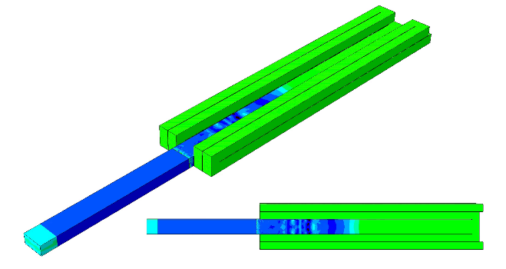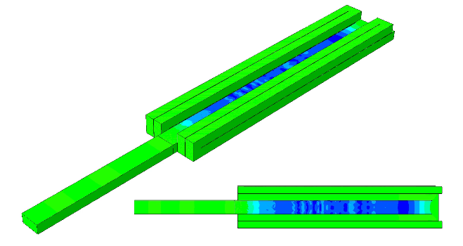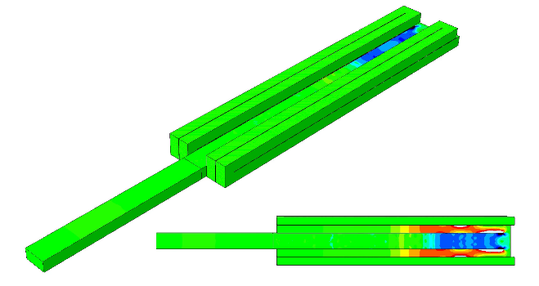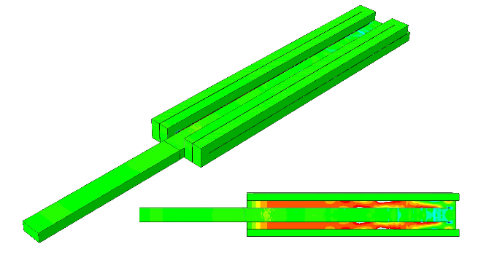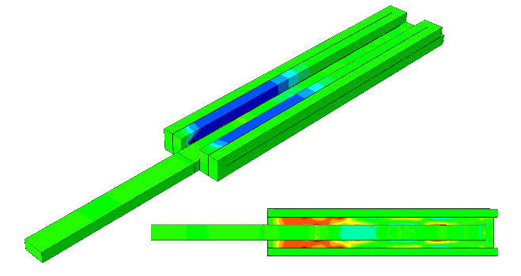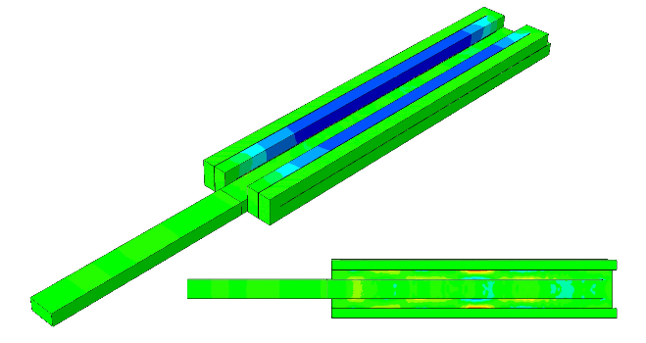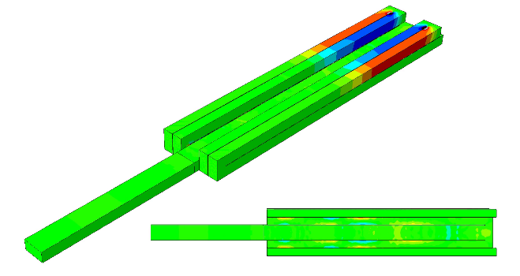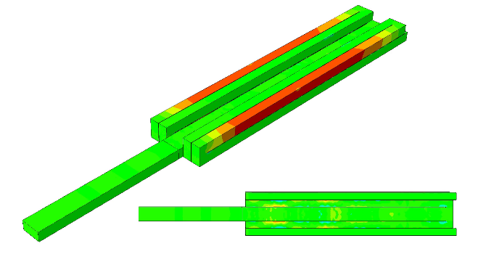
(h)
(g)
(f)
(e)
(d)
(c)
(b)
(a)
(j)
(i)
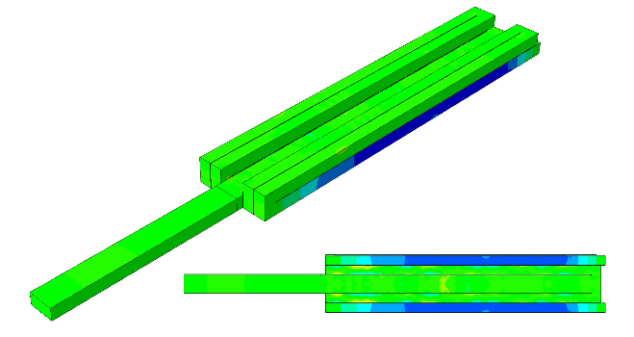
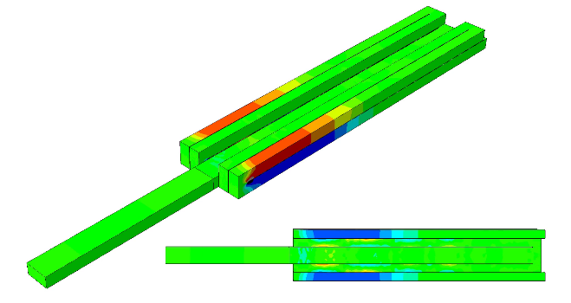
Fig. 5(a)-(j). Pulse propagation through millipede bar from short striker impact, isometric and underside views (still frames from animation). Compression is shown in blue, tension in red.

As Fig. 5 illustrates, the stress wave continues to flip between tension and compression after each junction as it propagates through Rods 3, 4, and 5. Consider the uniformity of the contour from the longitudinal pulse in Rods 3, 4, and 5, and compare to the non-uniform stresses observed in Rod2, where a slight “checkerboard” pattern of grey high-tension regions are briefly seen in Fig. 5(c), 5(d). For Bend2 and onward, the checkerboard pattern is not present. Observe Fig. 3 how the boundary conditions provide constraints on two orthogonal sides each for Rods 3, 4, and 5, while it is only possible to constrain Rod2 on the lower face due to geometrical limits of the millipede bar’s gaps and bends. This will be deeply explored later in the document with simulations having removed boundary conditions and the analysis of residual bending stresses.

Deformation direction of Bend1
It is noteworthy to illustrate the characteristic deformation of Bend1. Though the rectangular cross section will have highest compression, it is precisely due to the higher amount of mass (compared to the square cross-section of Rod2) that the deformation direction is outward, not inward (see Fig. 6 with exaggerated deformation scale). Again, this is a consequence of the lack of possible constraints on the other faces of Rod2, where Rods 3, 4, and 5 and the thin gaps in between impede direct placement of roller bearings or other bracketing design.
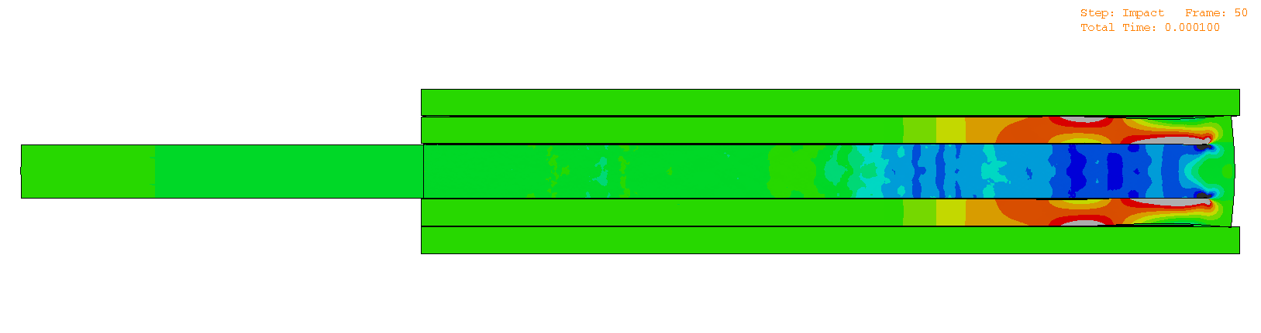
Fig. 6. Outward deformation direction of Bend1, visible after applying uniform deformation scale factor ×200. Some interference may occur on the model after applying high scale factor, which may be ignored—this does not indicate any actual self-contact.

ε vs. t (short striker)
The axial strain from each gage location is plotted against time in Fig. 7. There are five consecutive pulses as is consistent with 1D SHPB behavior. Since simulated boundary conditions are ideal compared to real-world, there is no loss of amplitude. A pulse width of ~75μs is observed in each, consistent with the 71.3μs pulse duration of an 18cm striker. Pochhammer-Chree oscillations are smoothed out after each pulse, consistent with lowpass filter behavior from the findings of 180° bend analysis [3]. Measurements align with positive and negative stress as the pulse alternates between compression and tension in each rod. From the properties of 6061-T6 aluminum, an impact velocity of 2m/s corresponds roughly to a strain amplitude of 200με.
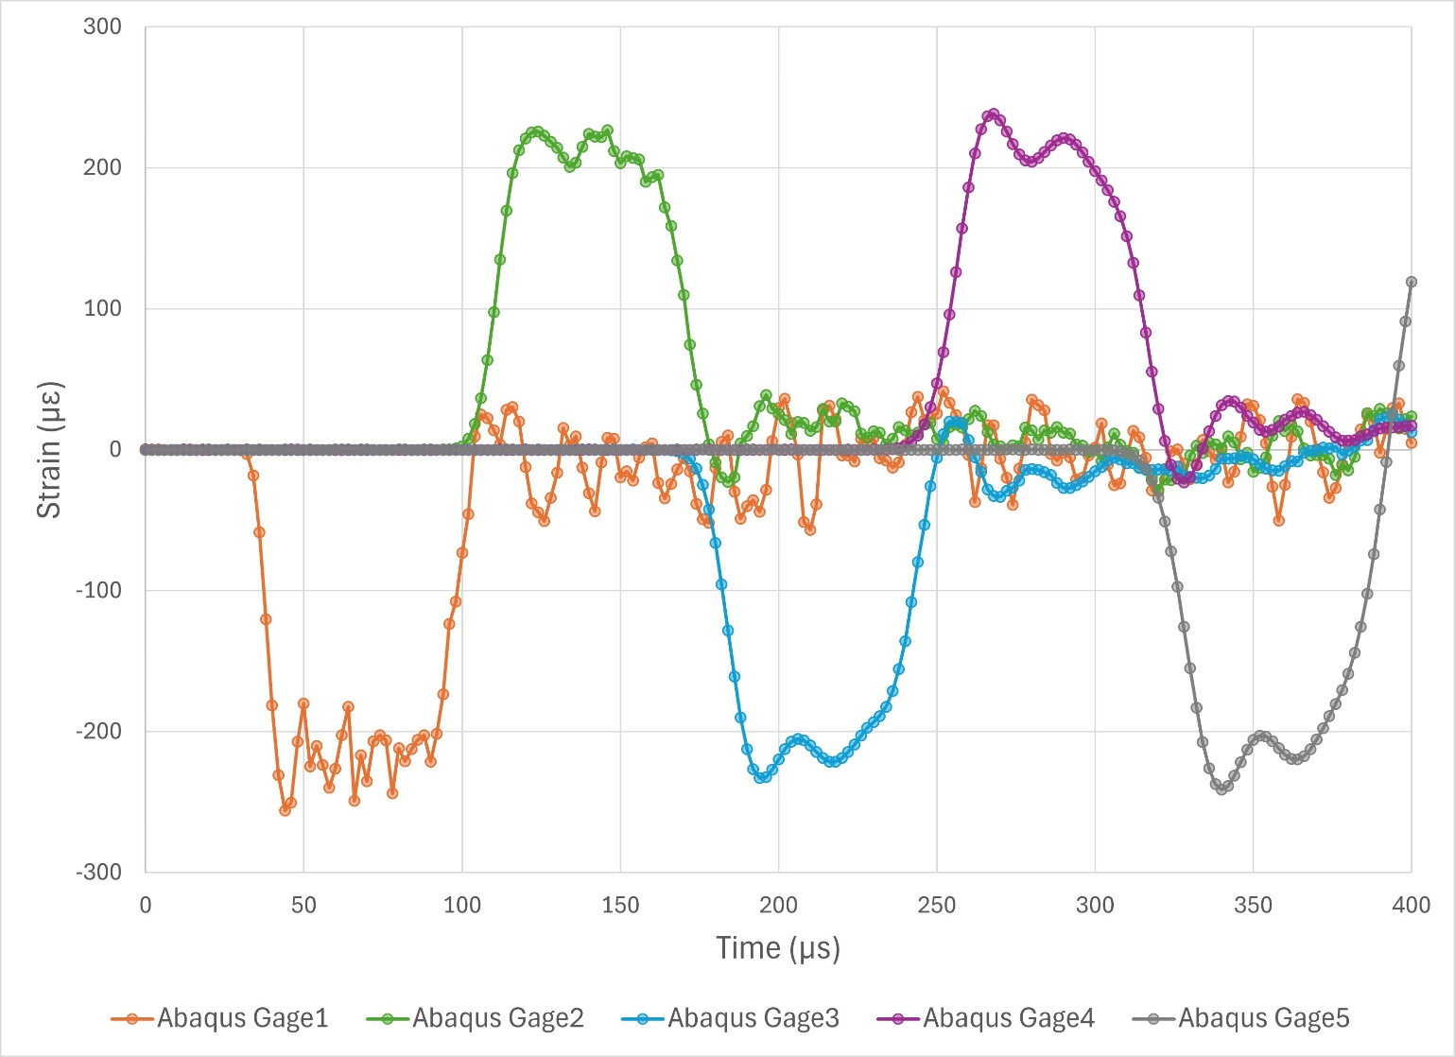
Fig. 7. Pulse obtained via simulation of short striker against millipede bar.

Long striker, 76cm (30in)
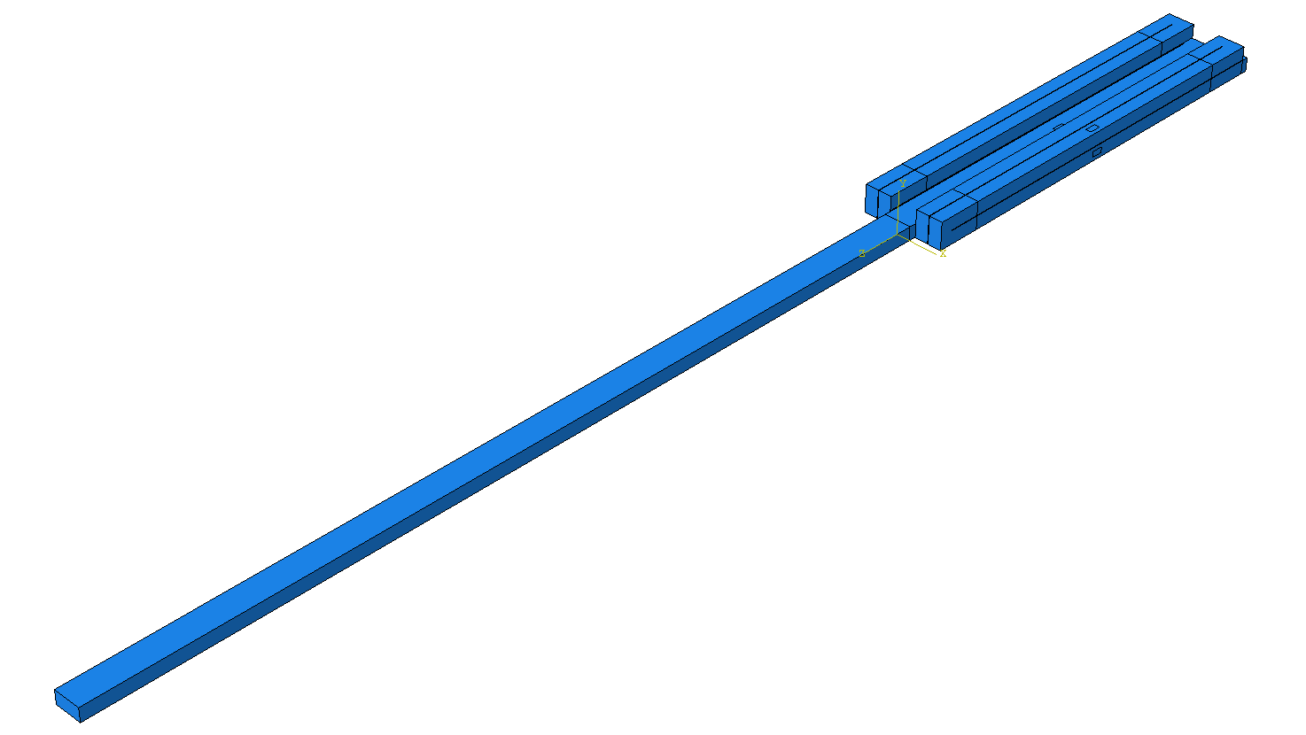
Fig. 8. Abaqus assembly of long striker with millipede bar.

Mesh & incrementation details (long striker)
With equal cross-sectional area, a striker bar of 76cm provides a pulse length of 152cm. Using a uniaxial wavespeed of 5,051m/s for 6061-T6 aluminum, the pulse duration is 1,520mm / (5,051m/s) ≈ 300μs. To capture five subsequent pulses—one from each segment of the millipede bar—a window of at least 5×300μs ≈ 1,500μs would be required. However, as seen with experimental results, the pulses are not subsequent and in fact overlap one another in time, as the pulse length is 152cm/36cm ≈ 4.22 times the side length of the millipede bar. Therefore, the pulse is detected at a gage before fully exiting the previous gage’s location. With the five gages each 36cm apart, period can be estimated as (4×71.3μs)+300μs ≈ 585μs, in order to reliably capture all pulses. To capture reflection, a period of 1,000μs was used, along with a stable time increment of 2×10⁻⁹ s, collecting data at 500 equal intervals.
A significant increase in elements was applied to achieve a finer mesh and provide measurements with higher fidelity. On the rectangular face of 76cm striker, nodes were placed every 2mm, and on the long edges, 38mm. This provided a 6×12×20 mesh of linear hexahedral elements, totaling 1,440 elements with 1,911 nodes. To compare against the short striker’s mesh, an image is provided for the long striker’s mesh in Fig. 9. Impact striker velocity was increased to 5m/s to achieve higher amplitudes in the strain vs. time curve and examine pulse shapes.
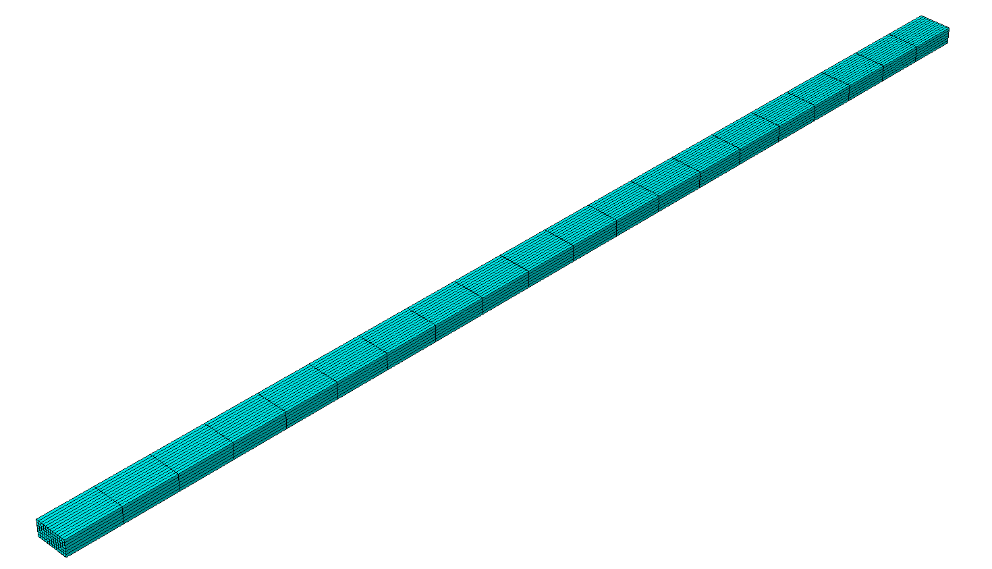
Fig. 9. Generated mesh for the long striker.
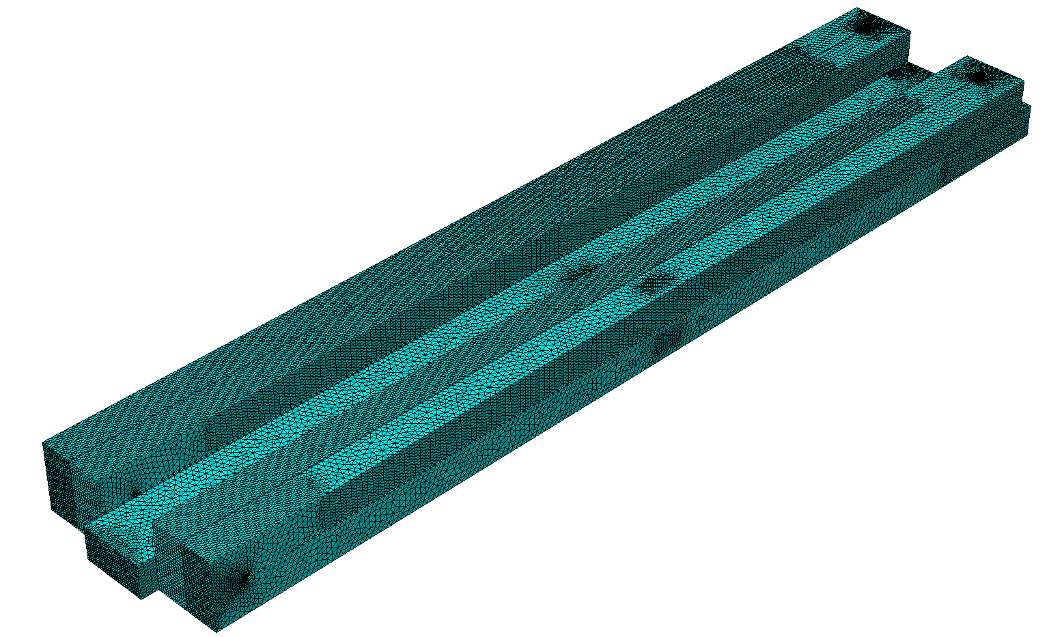
Fig. 10. Mesh for millipede bar with significant increase in elements. Concentrations on impact face, junction faces, gage locations, and fillets were created while long edges were given nodes wider apart to preserve memory space. Note how the boundary condition partitions are now more visible due to the differences in concentration and Abaqus’ programmatic assignment of nodes.
For the 76cm striker simulation, the mesh for the millipede bar was made finer by reducing the distance between nodes. Gage regions have nodes 1mm apart; so do the fillets, with 4 nodes about each semicircle. The impact face and junction faces, all 12mm×24mm, also have nodes 1mm apart, creating areas measuring 12×24 elements. The remaining 36cm long edges were given nodes spaced 2mm apart for memory conservation. As seen in Fig. 10, these criteria produced 812,001 quadratic tetrahedral elements with 1,215,524 nodes.

Contour plot (long striker)
[Object 2 – Animation, millipede bar axial stress, long striker with boundary conditions]
The animation provided in Object 2 shows the pulse from the long striker traveling through all 5 rod segments of the millipede bar via measurement of axial stress, S33, with isometric and underside views. Fig. 11 shows still frames up to frame #244, corresponding to 480μs, where the reflection from the free end of Rod5 cancels out the remaining pulse until the millipede bar is in a zero-stress state. (Note in Fig. 11(i) how Rod2 displays residual stresses, both compressive and tensile, due to its lack of boundary conditions, while the other segments are comparatively “cleaner” in their equilibrium).

ε vs. t (long striker)
The plot in Fig. 12 illustrates the results of axial strain against time, and we see expected ideal behavior from a long striker against millipede bar with sufficient boundary conditions. Rectangular pulses are present, each one initiating before the pulse fully exits the previous gage, and the Pochhammer-Chree oscillations are again smoothed out via lowpass filter behavior. Reflections after 250μs are noticeably more varied at their highest amplitudes. Fig. 13 shows the same plot, with period cut off at 500μs (frame #250), in order to have a closer look at the initial pulses only. As before, amplitudes do not lessen in magnitude due to the idealized constraints.

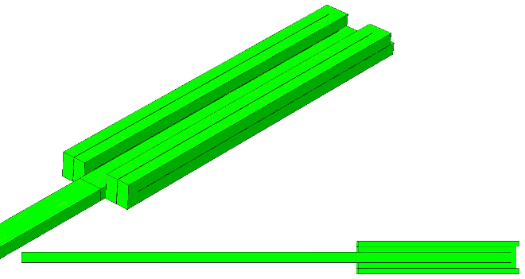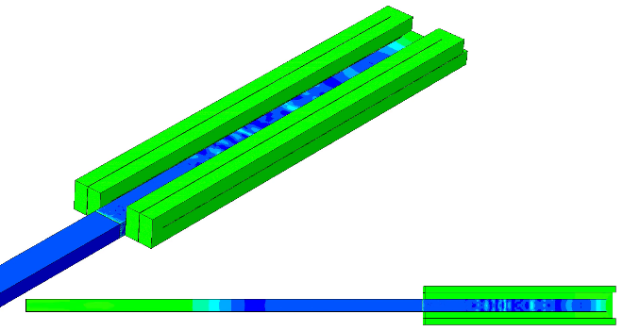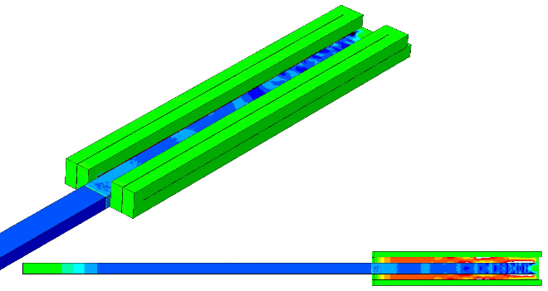
(g)
(h)
(d)
(e)
(a)
(b)
(c)

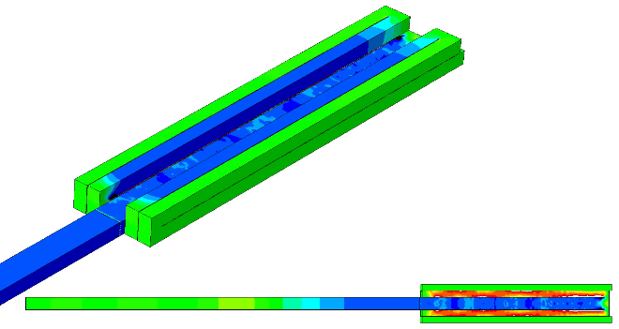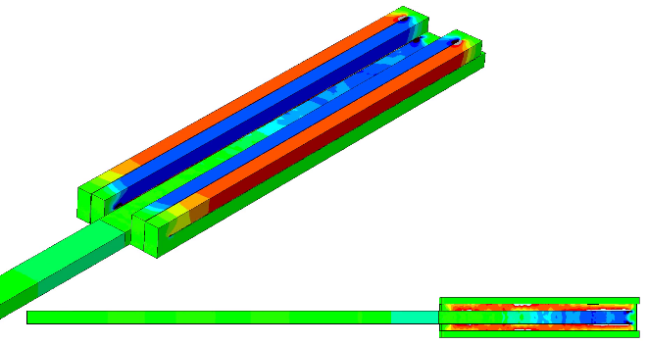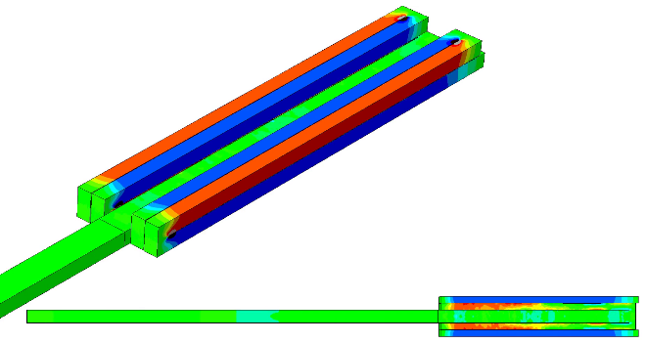
(f)

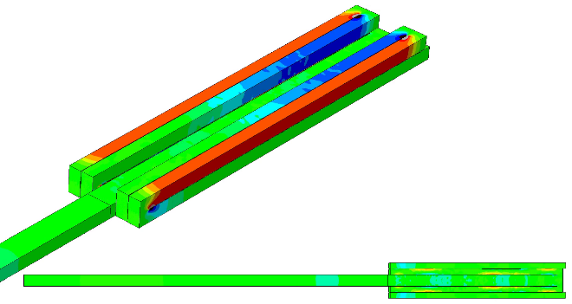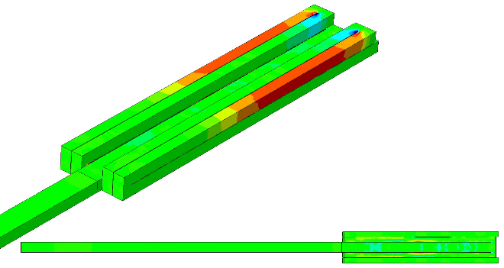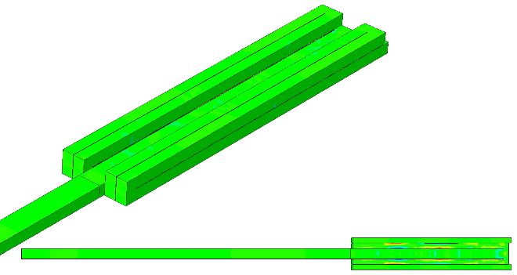
(i)
Fig. 11(a)-(i). Pulse propagation through millipede bar from long striker impact, isometric and underside views (still frames from animation). Compression is shown in blue, tension in red.

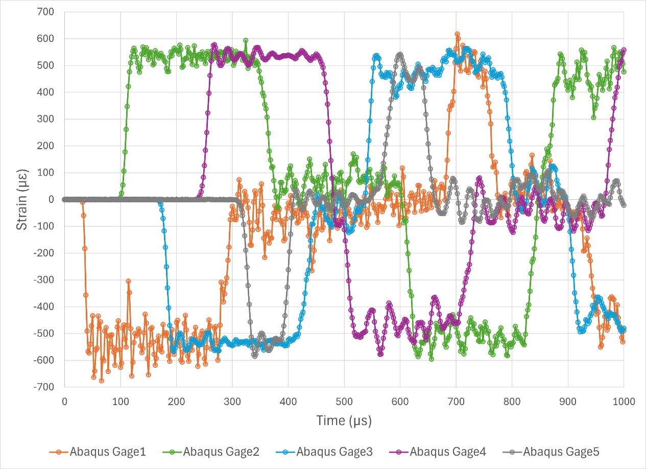
Fig. 12. Pulse obtained via long striker against millipede bar, up to 1,000μs.
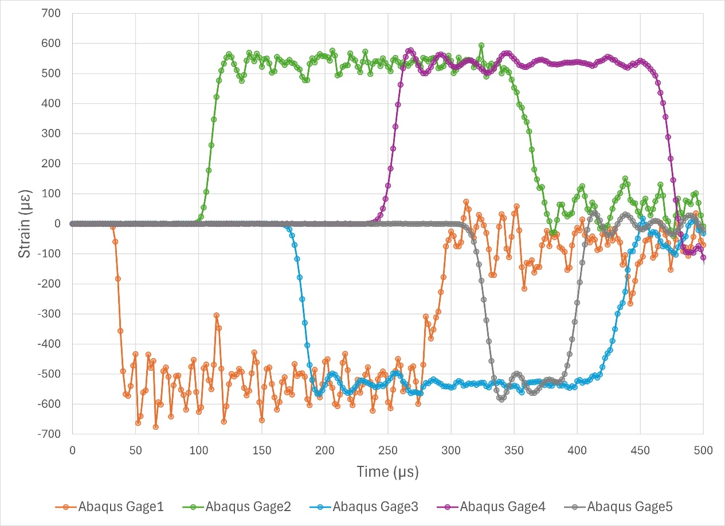
Fig. 13. Pulse obtained via long striker against millipede bar, up to 500μs.

Millipede striker
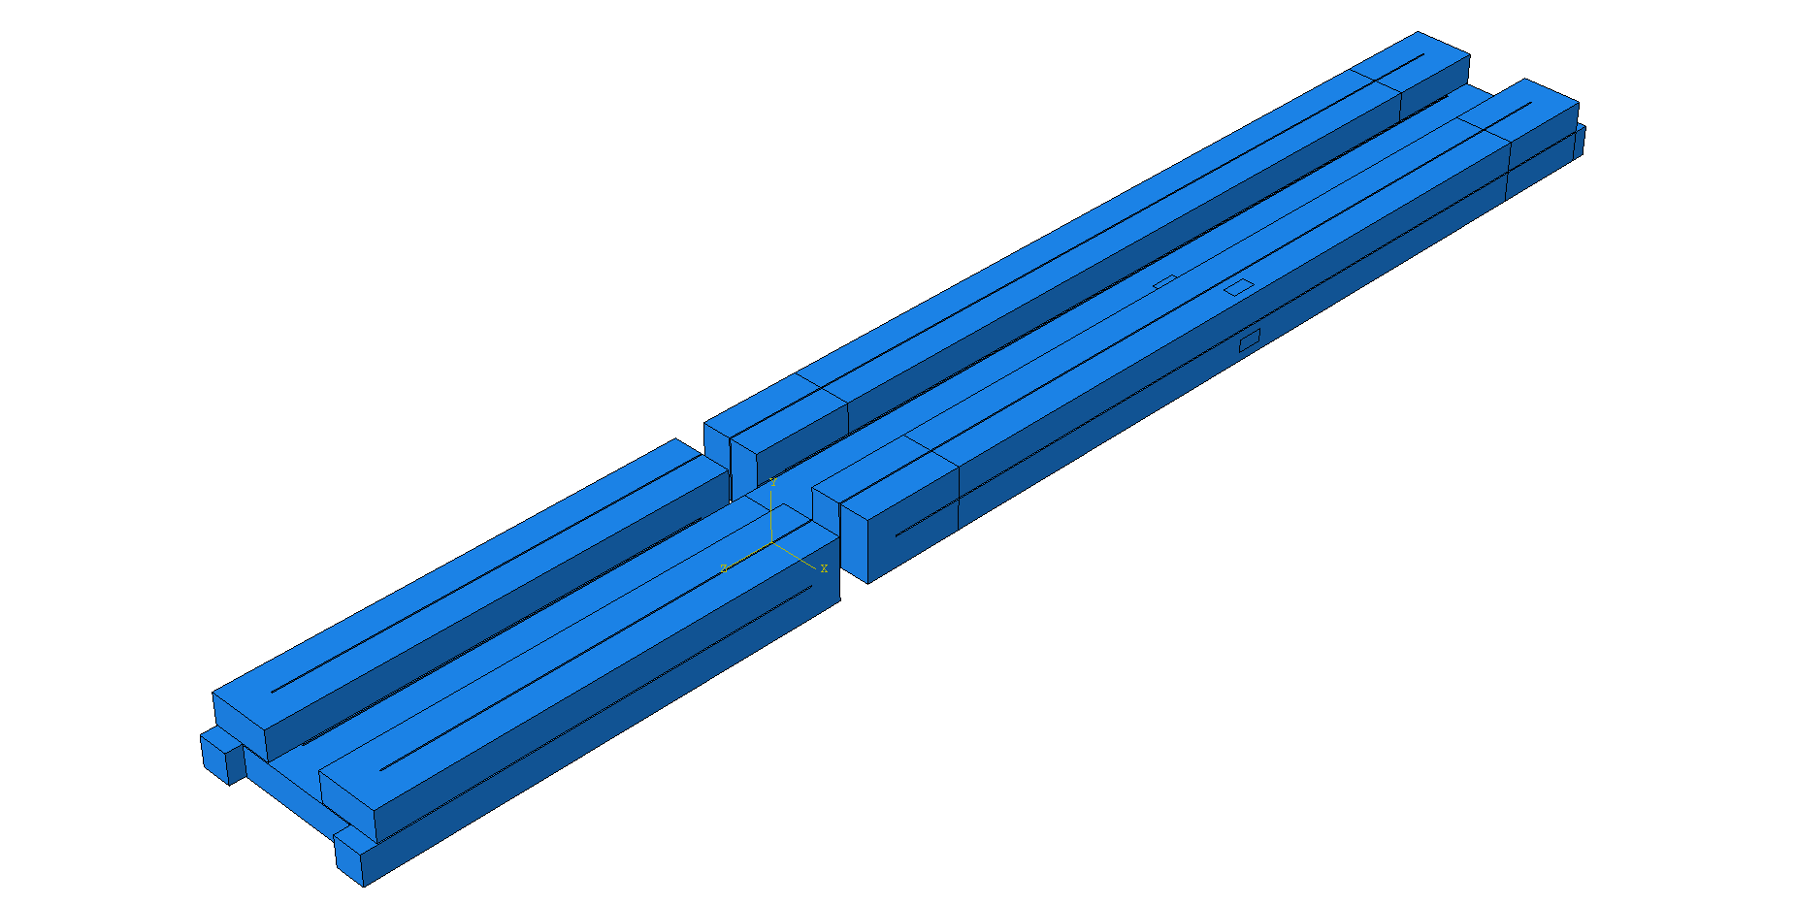
Fig. 14. Assembly of striker millipede bar against incident millipede bar.

Mesh & incrementation details (millipede striker)
Since it is known to have similar acoustic length, the same incrementation details as with the long striker were used: a period of 1,000μs, stable time increment of 2×10⁻⁹ s, collecting data at 500 equal intervals. The same mesh details as with the long striker simulation were also used on the incident millipede bar, but due to the programmatic generation of elements in Abaqus, different totals were obtained: 811,812 total quadratic tetrahedral elements with 1,215,289 nodes. Refer to Fig. 10 as the mesh was nearly identical between these two simulations.
For the striker millipede bar, a coarser mesh was utilized for memory conservation. Fillets, impact face, and junction faces had nodes 2mm apart. Fillets were then 6 elements long, again with 4 divisions on each semicircle. Impact face and junction faces had areas measuring 6×12 elements. The remaining 36cm long edges were given nodes spaced 4mm apart. These criteria resulted in 83,608 quadratic tetrahedral elements with 131,534 nodes. Fig. 15 displays the mesh of the half-scale millipede bar striker. Same as the long striker, impact velocity was set to 5m/s.
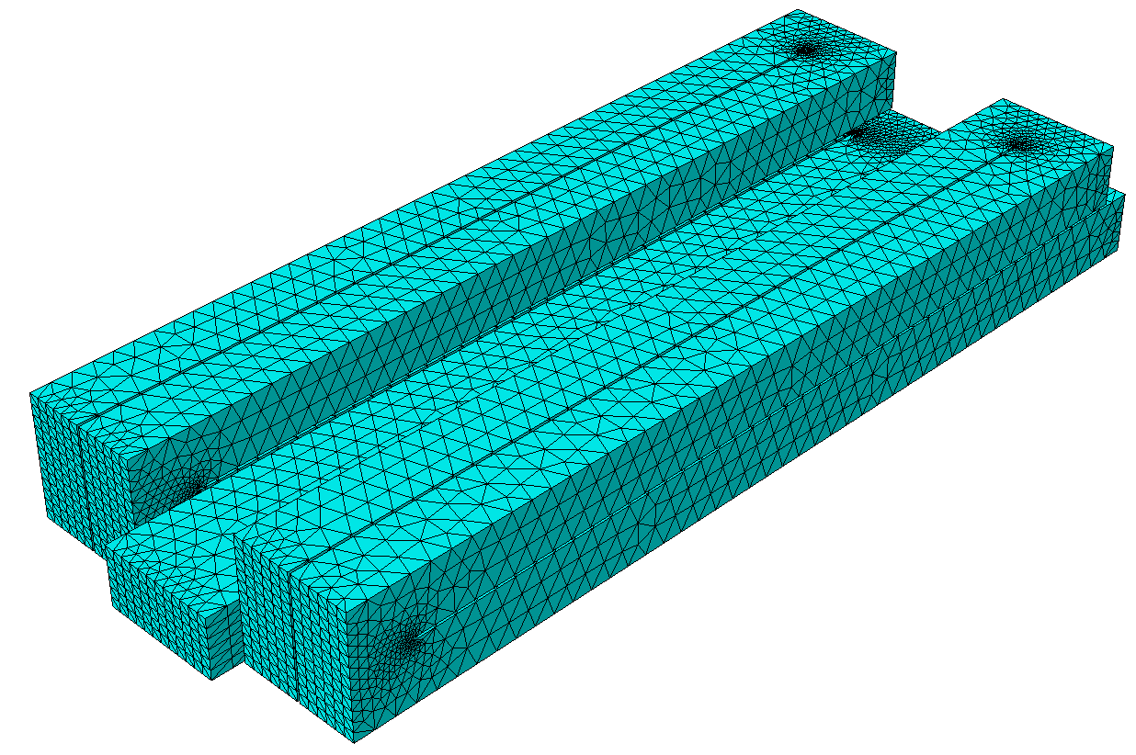
Fig. 15. Mesh for the half-scale millipede striker bar, less fine than the mesh used for the incident millipede bar.

Contour plot (millipede striker)
[Object 3 – Animation: incident millipede bar axial stress, half-scale striker millipede bar, with boundary conditions]
The animation provided in Object 3 shows the pulse from the half-scale millipede striker traveling through all 5 rods of the incident millipede bar via measurement of axial stress, S33, with isometric and underside views. Fig. 16 shows still frames up to frame #257, corresponding to 514μs, where the reflection from the free end of Rod5 cancels out the remaining pulse until the incident millipede bar is in a zero-stress state. (Note again in Fig. 16(i) how Rod2 displays residual stresses, both compressive and tensile, due to its lack of boundary conditions, while the other rods are comparatively “cleaner” in their equilibrium). The striker millipede bar as well experiences switching between compression and tension in each rod as the pulse travels through each of its bends and provides a compressive pulse equal to twice its acoustic length (2×5×18cm = 180cm).
(a)
(b)
(c)
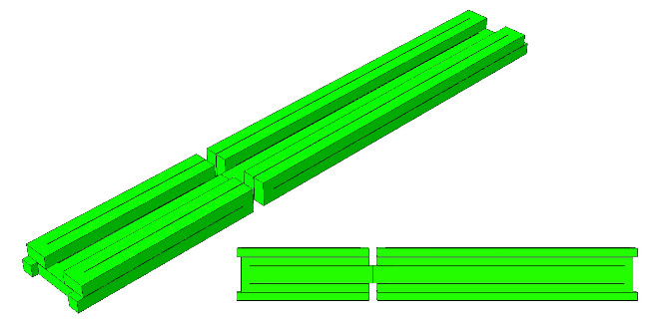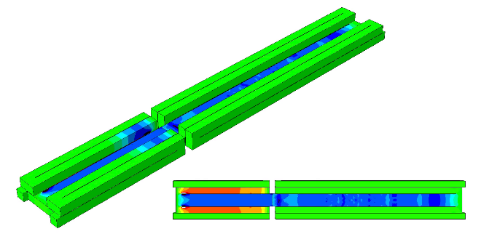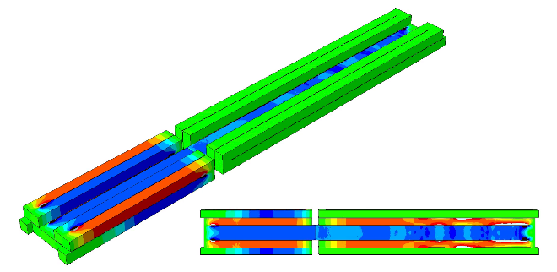

(d)
(e)
(f)
(g)
(h)
(i)
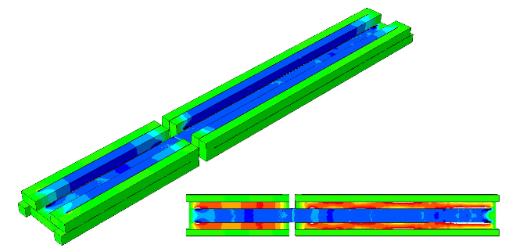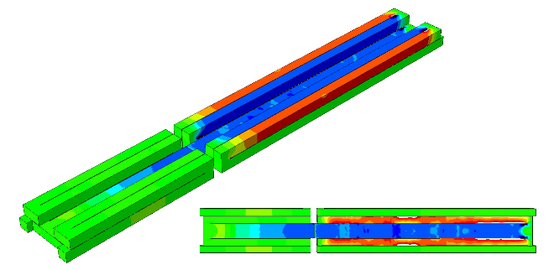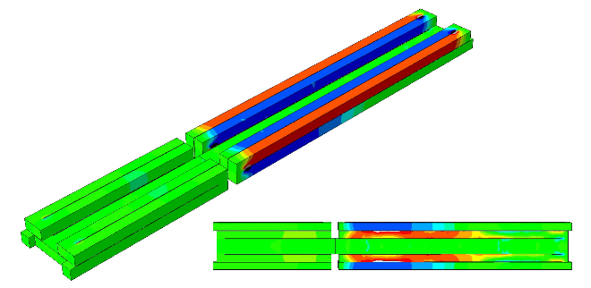

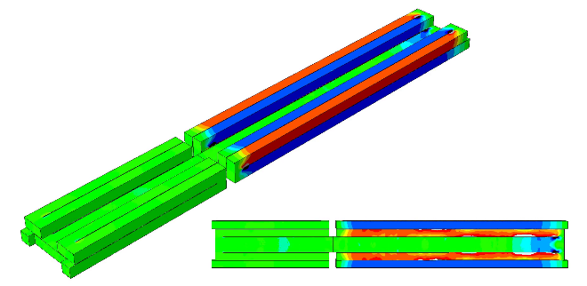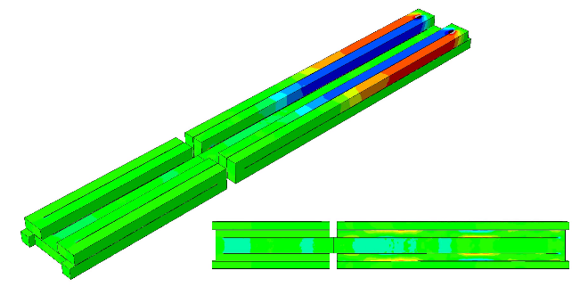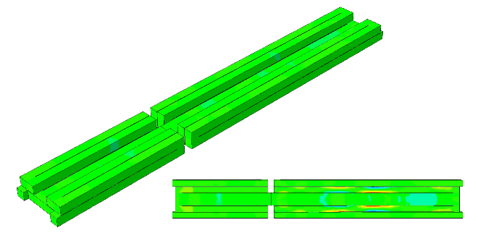

Fig. 16(a)-(i). Pulse propagation through incident millipede bar from half-scale millipede bar striker impact, isometric and underside views (still frames from animation). Compression is shown in blue, tension in red. Striker millipede also experiences switching between compression and tension after pulse travels through each junction.

ε vs. t (millipede striker)
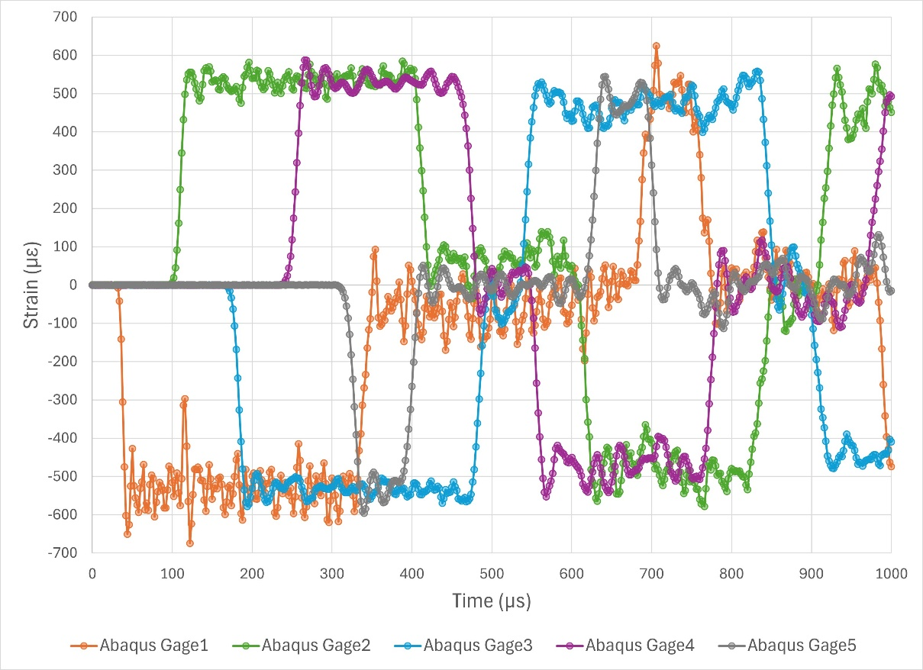
Fig. 17. Pulse obtained via half-scale millipede striker against incident millipede bar, up to 1,000μs.
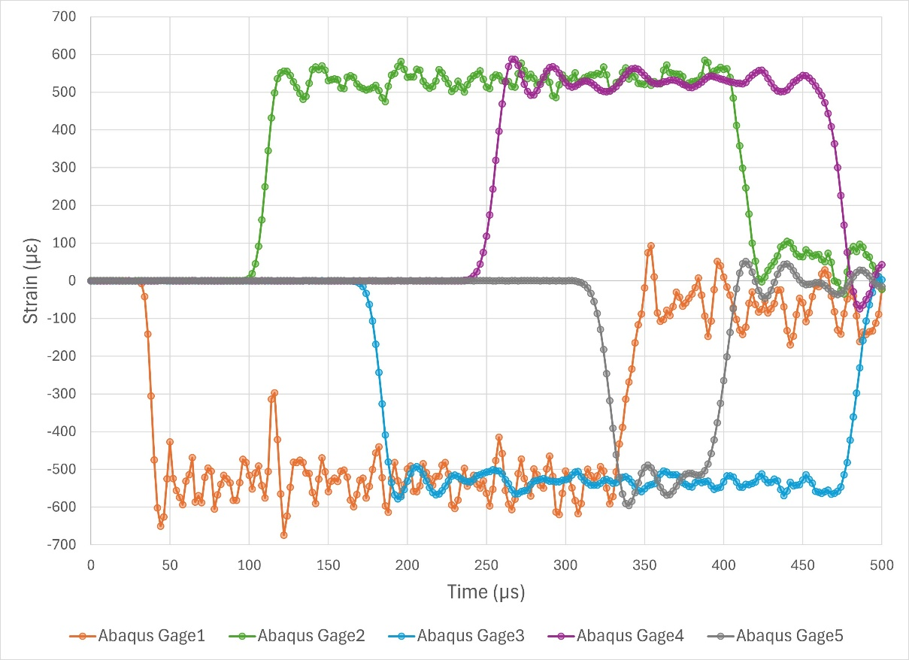
Fig. 18. Pulse obtained via half-scale millipede striker against incident millipede bar, up to 500μs.

Agreement with long striker
In the corresponding strain vs. time plot, the pulse behavior matches closely with that of the 76cm long striker, albeit with longer pulse duration, which is expected from the greater acoustic length of the half-scale millipede striker equal to (5/2)×18cm = 45cm, and associated pulse length 90cm. Compare Fig. 17 to Fig. 12 and Fig. 18 to Fig. 13 for the relevant periods, 500μs and 1,000μs, respectively. Lowpass-filter smoothing of oscillations is more legible in the 500μs figures; amplitude degradation from reflected pulses is observable in the 1,000μs figures.
Let us establish upper and lower bounds of acceptable simulated pulse duration findings. For the 76cm striker, it was stated that a pulse duration of 300μs is predicted, and simulation results from Fig. 13 show an agreement, with pulse length roughly 275μs presented in Rods 1-3. Likewise, the half-scale millipede striker is predicted to have a pulse duration of 1,800mm / (5051m/s) ≈ 356μs, which agrees closely with the results of Rods 1-3 from Fig. 18, at roughly 325μs. We establish the lower bounds of estimation using the longitudinal wavespeed of bulk 6061-T6 aluminum, 6,425m/s [4]. This gives pulse durations of ~236m/s for the long striker and ~280μs for the millipede striker. The Abaqus results fit neatly in between the bulk and axial limits: for the long striker, 236m/s < 275m/s < 300m/s; for the millipede striker, 280m/s < 325m/s < 356m/s.

Gage5 & Gage4 pulse behavior
However, it is clear in both the long striker and millipede striker scenarios that Rods 4 and 5 have shorter pulse durations than proceeding rod segments. Interestingly, for both the long and millipede strikers, despite their different acoustic lengths, both outcomes of Rod4 show a pulse around 225μs, and for Rod5 even shorter, around 75μs. This is explained by the placement of gages in the middle of each rod segment and the free end of Rod5. Clearly, Gage5 is at a distance from the free end (18cm) much shorter than the pulse length in both cases. Similarly, Gage4 is at a distance 3×18cm=54cm from the free end, also much shorter than each pulse length. The reflected pulse superimposes onto the rest of the oncoming pulse, cancelling out incoming compression with reflected tension (refer to Figs. 11(f)-(i) and 16(f)-(i) for visualization). This neutralization from the free end occurs at the same ratio for each acoustic length, thus Gages 4 and 5 measure similar pulse durations. This can be expected at any gage placed a distance less than the striker length from the free end. Note: Gage3 is at a distance 5×18cm = 90cm from the free end and so it measures the full pulse duration.

Impact velocity & strain amplitude
It is worthwhile noting that increased impact velocity between short striker and long striker simulations—from 2m/s to 5m/s—resulted in a correspondingly linear increase of axial strain amplitude—from ~200με to ~500με. This reinforces an elementary understanding of dynamic stress response from SHPB. Though the striker increases in mass by 76/18 ≈ 4.2, and kinetic energy would increase by the same factor, the axial strain amplitude does not increase by 4.2, but instead by 5/2 = 2.5. This is explained by linear elasticity, σ = Eε, along with $σ= \frac{1}{2}ρC_{L}v$, the equation for axial stress of a SHPB with equal material properties and cross-sectional area between striker and incident, with negligible or no specimen, where ρ is density, C_{L} is longitudinal wavespeed of the material, and v is striker velocity [5] [6]. From these relations, using longitudinal wavespeed of 6061-T6 aluminum in a bulk material C_{L} = 6,425m/s for a conservative estimate, an approximate real-world striker velocity was calculated from experimental values as 5.42m/s for the short striker and 4.58m/s for the long striker. This legitimizes the assumptions of 5m/s and lesser striker velocities used in Abaqus simulations.

Without boundary conditions
It is evident from the contour plots that after passing Bend2, well-constructed constraints will lead to clean longitudinal pulses, without flexural or shear wave behavior interfering. This gives great promise for use of a 3D millipede bar in normal SHPB industrial and research applications; nevertheless, these ideal simulated results do not match current experimental data. We ventured to run simulations with boundary conditions in Fig. 3 removed to assess the quality of 3D-printed brackets. It also revealed vibrational modes of the millipede bar, i.e., directions of deformation for each rod & bend junction as the pulse travels around each bend.

Short striker, 18cm (7in), no constraints

Mesh & incrementation details
The same mesh criteria as in in the previous short striker simulation was used, but with partitions for boundaries removed, the total number of generated elements differed. The total number of quadratic tetrahedral elements generated was 869,960, with 1,297,161 nodes (Fig. 19).
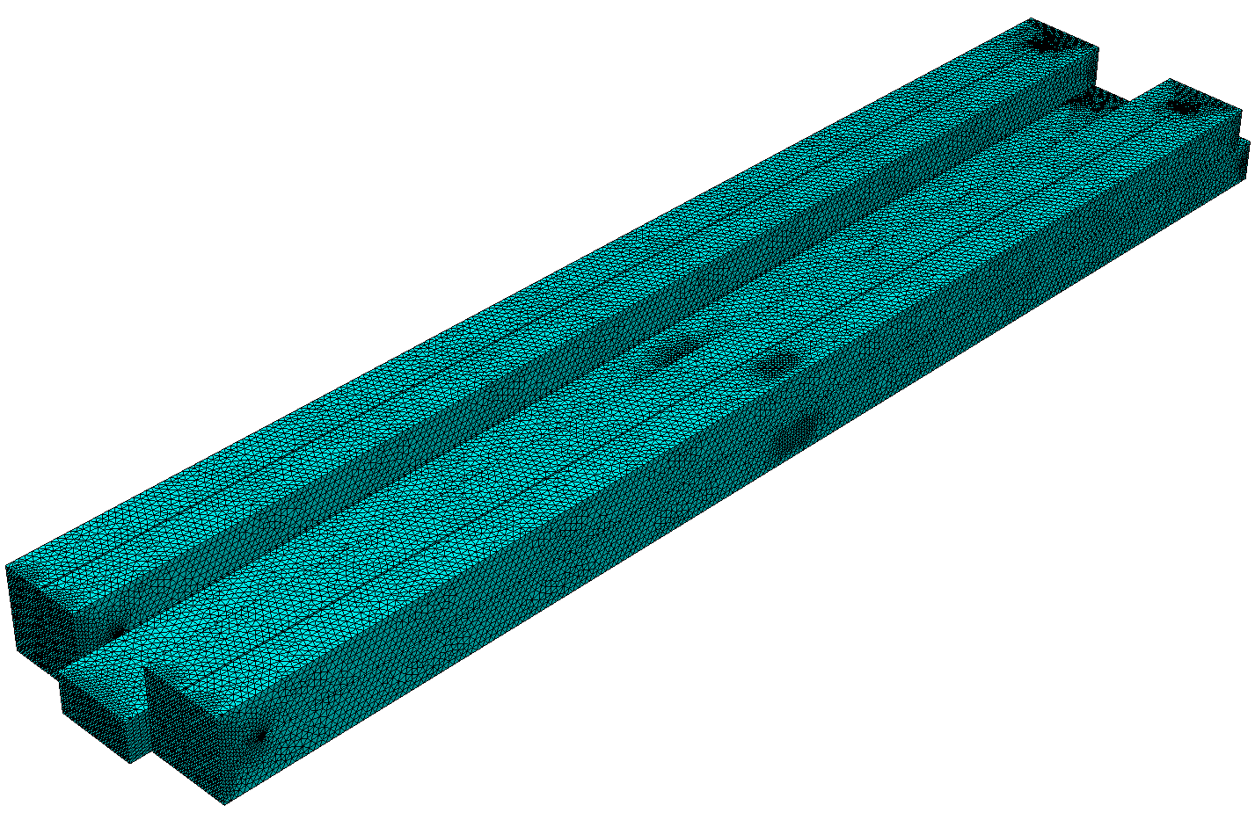
Fig. 19. Mesh for millipede bar showing even distribution of elements after removal of partitions for simulated boundary conditions.
Impact velocity was reduced to 1m/s to see if any pulse shape variation occurred from lower strain amplitudes combined with removal of boundary conditions. Of course, altering impact velocity in simulation is largely inconsequential; this was verified by agreement with experimental short striker results and comparison to the unconstrained long striker simulation’s contour plot.

Contour plot (short striker, no constraints)
[Object 4 – Animation: millipede bar axial stress, short striker, no BCs, deform scale x1]

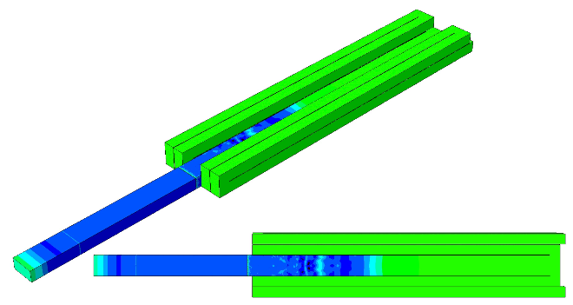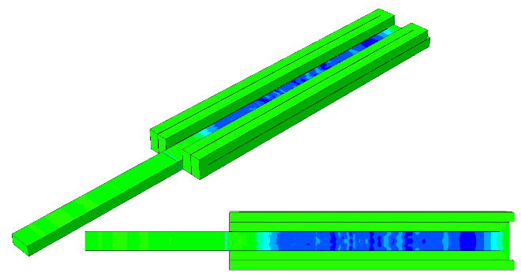
(b)
(a)
(c)
(d)

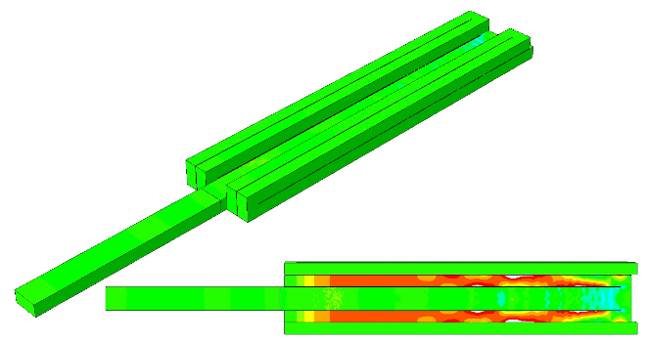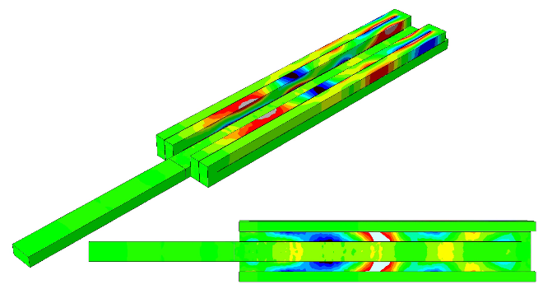
(f)
(e)
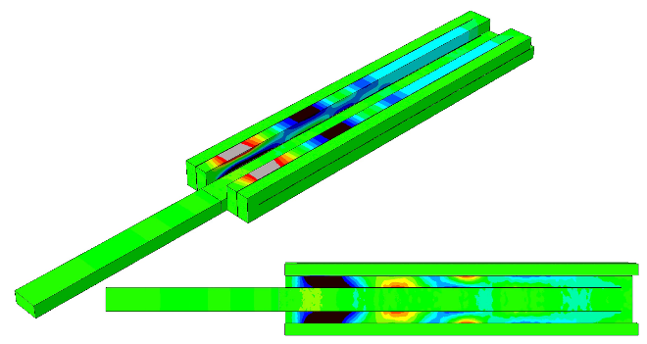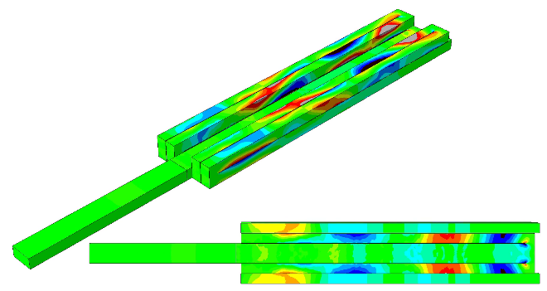
Fig. 20(a)-(f). Pulse propagation through millipede bar with no boundary conditions from short striker impact, isometric and underside views (still frames from animation). Compression is shown in blue, tension in red. After Bend2, the stress distribution is extremely non-uniform: in each rod are mixed regions of high tension, high compression, and neutral areas in between.

ε vs. t, experiment vs. simulation (short striker, no constraints)
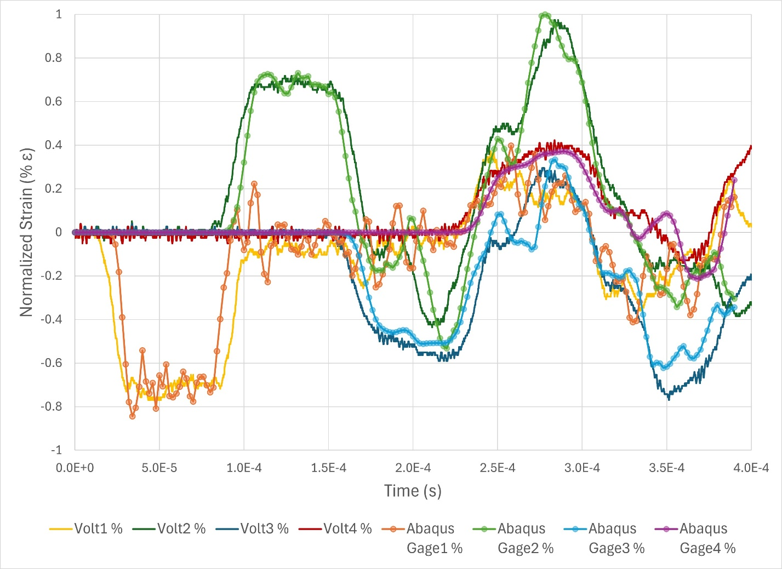
Fig. 21. Axial strain from millipede bar after impact by short striker (18cm), experiment compared against unconstrained Abaqus model, each signal normalized against its own maximum absolute value reading. Data in 200 frames captured up to 400μs.
In Fig. 21, signals from Gages 1-4 are shown, both from experiment and Abaqus findings. Each dataset is normalized against its respective maximum absolute value. Gage5 is not shown due to a limitation of 4 signal amplifiers in experiment but follows a similar trend and can be viewed in Appendix A. When boundary conditions are removed from the Abaqus simulation, the signals match those from experiment, implying that plastic brackets are insufficient in constraining the real-world millipede bar to allow only axial motion. Amplitudes reduce in magnitude after each junction and the quality of rectangular pulses also diminishes. After each initial pulses, there are alternating peaks of compression & tension present, the largest of which is at Rod2, at 288μs.

Long striker, 76cm (30in), no constraints

Mesh & incrementation details
The same node criteria as in the constrained long striker simulation was used, but with partitions for boundaries removed, the total number of generated elements differed. The total number of quadratic tetrahedral elements generated was 862,473, with 1,287,008 total nodes. Striker velocity was 2m/s. Refer to Fig.19 for a visual, as resulting meshes are nearly identical.

Contour plot (long striker, no constraints)
[Object 5 – Animation: millipede bar axial stress, long striker, no BCs, deform scale x25]
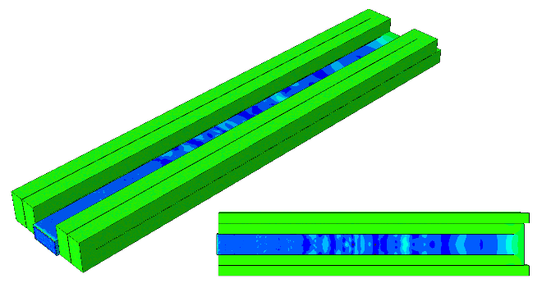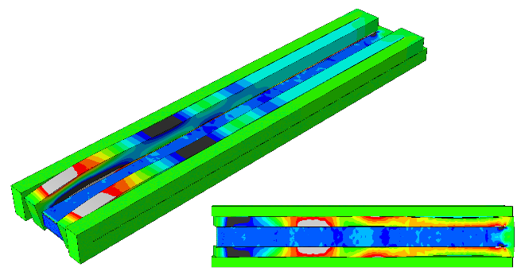
(b)
(c)
(a)
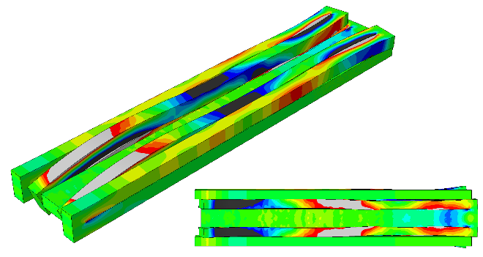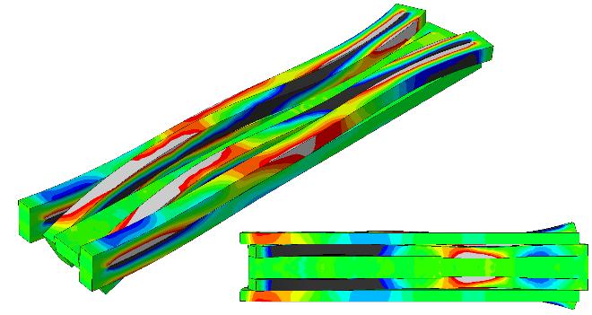
(f)
(d)

(e)
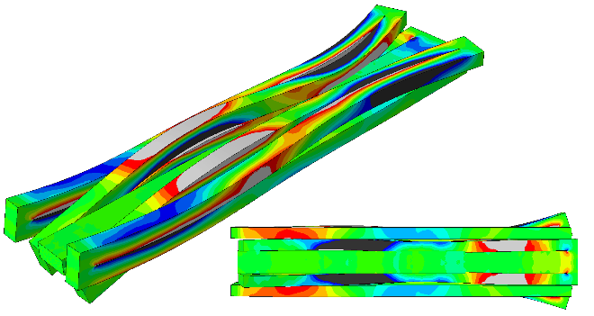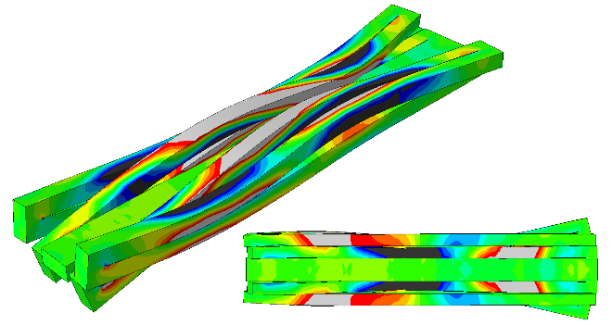
1

Fig. 22. (a) and (b) Vertical motion of the junction between rods 2 and 3 and bending, (c), (d) and (e) combined vertical and horizontal motion of the bends and rods, (e) and (f) twisting of the bends and rods (deformation scale ×50). Note non-uniform stress distribution at each cross-section.

ε vs. t, experiment vs. simulation (long striker, no constraints)
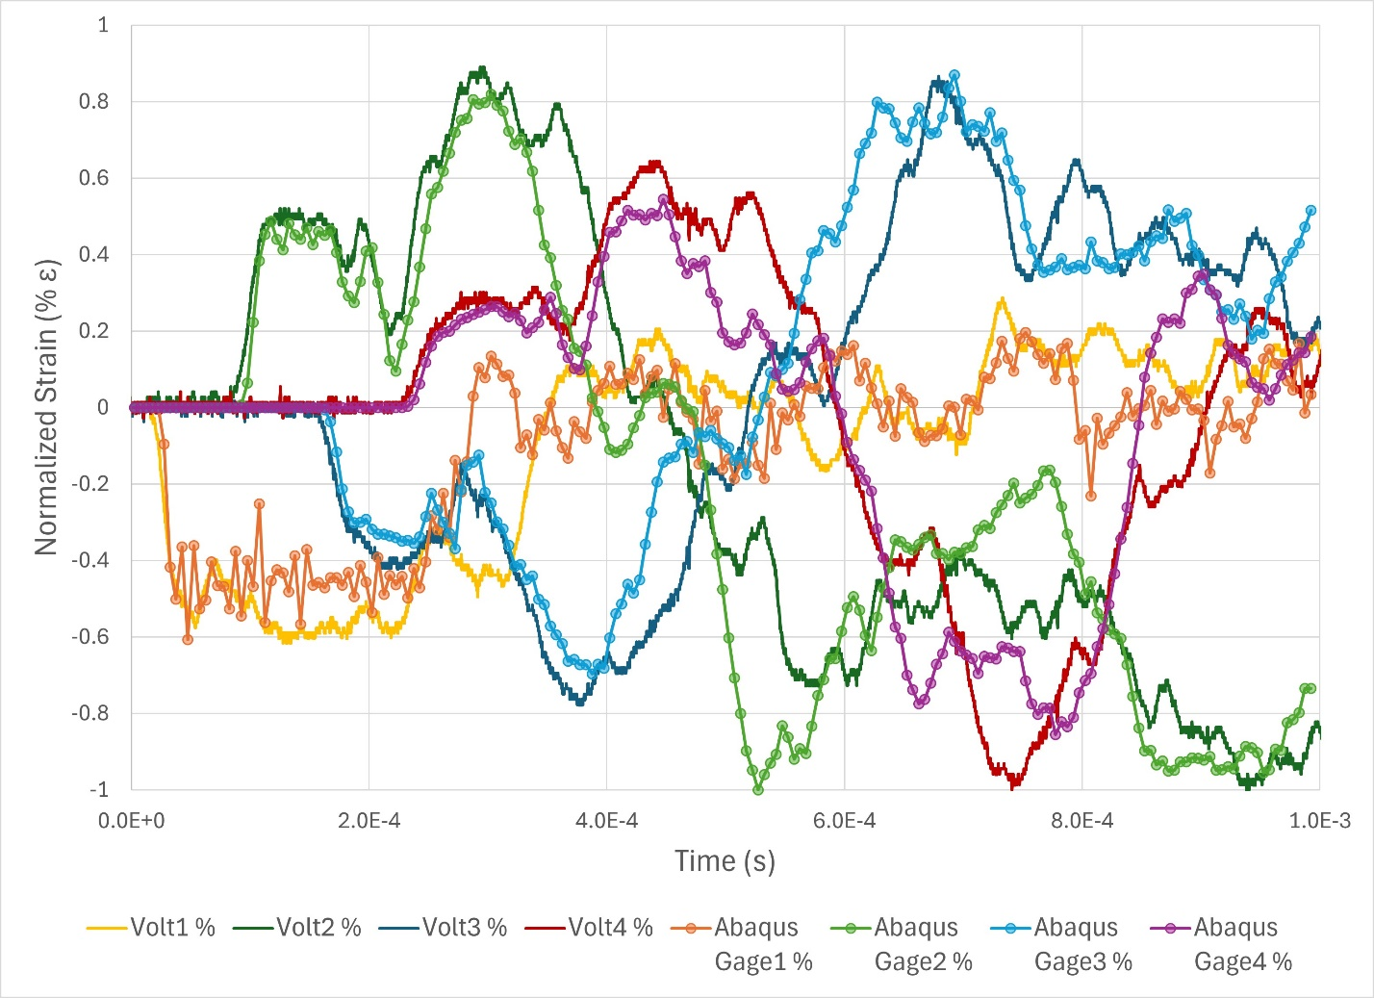
Fig. 23. Axial strain from millipede bar after impact by long striker (76cm), experiment compared against unconstrained Abaqus model, each signal normalized against its own maximum absolute value reading. Data captured in 200 frames up to 1,000μs.
Fig.23 follows the same details as Fig.21; Gage 1-4 signals are shown, while Gage5 is not present due to maximum 4 signal amplifier channels (Gage5 Abaqus result is in Appendix A). Each dataset is normalized against its respective maximum absolute value, but here, the highest value is in compression: in Rod2 for the Abaqus simulation, Rod4 from experiment. There is even lesser quality of rectangular pulses and the initial pulse is “interrupted,” i.e., there are spikes of increased tension/compression before each pulse reaches zero strain (besides Gage1). There is higher dissent between Abaqus and experiment after 500μs; also, there is a notable Gage1 discrepancy at 300μs. Despite these details, there is general agreement between the two trends.

Bending stress analysis
Unconstrained, axial strain is still predominantly measured, up until oscillations appear following the otherwise rectangular pulses. The Abaqus results with boundary conditions imply that these spikes can be reduced or removed with enhanced constraints. After removal of boundary conditions, why are pulses so drastically changed?
With a general 3D understanding, we realize that each junction introduces a new dimension to the initial 1D pulse. If the initial pulse on Rod1 is understood as the axial z-direction, then clearly at Rod2 the pulse is introduced to a new x-direction, and Rod3 introduces the y-direction. Rod4 also turns from the x-direction and Rod5 from the y-direction. Though the pulse is reflected in the axial z-direction, ultimately there is bending motion occurring when boundary conditions are unincorporated into the model.
In a basic problem of a beam undergoing bending stress, there exists a neutral axis where stress neutralizes to zero between the surface under compression and the opposite surface undergoing tension. For the millipede bar, although the neutral axes must be in complicated 3D orientations between junctions, they must nonetheless exist somewhere. Although the pulse is highly nonuniform after travelling through Rod2, the contour plots in Figs.20(f) & 22(f) display not only high tension and high compression regions, but neutral areas naturally in between.

High-tension spike in Rod2
To investigate, we selected the moment of peak tension in Gage2 (at 288μs) of the short striker’s results in Fig.21. It was surmised that at some other location on the Rod2 cross-section, there would be a noticeable neutral axis alongside a region of high compression. However, after initial pulse, bending stress should be close to 0 somewhere along Rod2 due to existence of a neutral axis. This is significant for one because in the real-world experiment, it is impossible to place a strain gage on any other face on Rod2. There is of course not enough clearance available in the gaps and the other rods surround Rod2 except only for the underside face.

Face 90° from Gage2
A section cut view was utilized to view the other faces of Rod2 at the midpoint cross-section, allowing us to see through Rods 4 and 5. Indeed, at 288μs, a region of neutral stress was found on a face 90° to that of the Gage2 location, seen in Fig.24. A “Point Gage” partition was created here to extract strain measurements and compare with those from Gage2, seen in Fig.25. At this Point Gage, we expect the pulses to be roughly equivalent during the initial pulse from predominantly axial strain, then closer to zero around the time that Gage2 reaches its peak tension. (We will also observe tensile behavior at 230μs, where Gage 2 experiences compression and a local minimum as seen in Fig.21.)
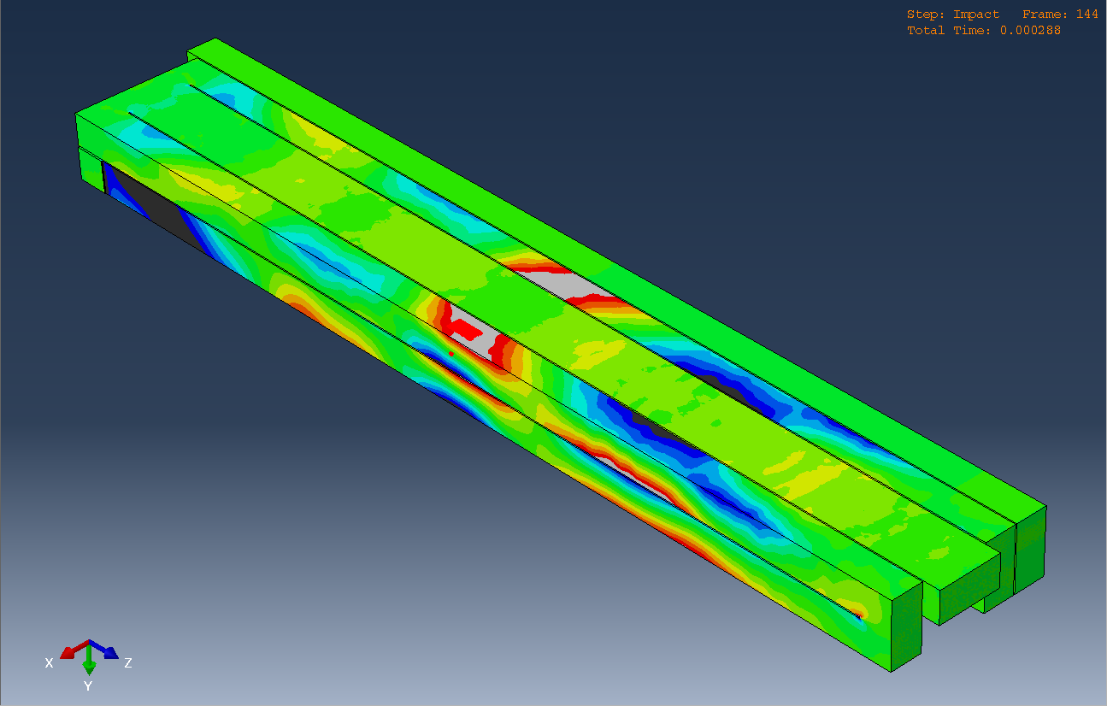
Gage2
Point Gage
Section Cut
Section Cut
Fig. 24. Underside of millipede bar with section cut view, removing Rod4 and Rod5 from view on one side. Gage regions are shown in red outlined with white dashed boxes. This frame is 288μs after initial impact, at the peak tension of Rod2.
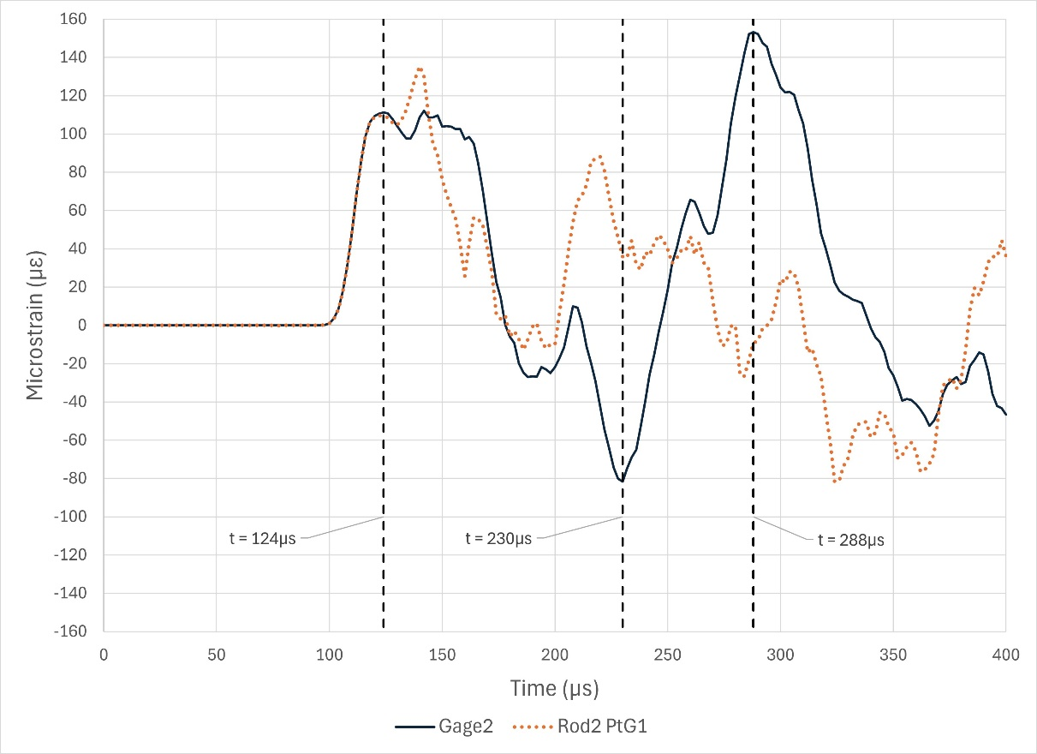
Fig. 25. Strain vs. time for short striker, unconstrained, measured at Gage2 and a Point Gage on a face orthogonal (90°) of Gage2.
Analyzing the patterns between Gage2 and the Point Gage on the orthogonal face, the axial strain measurement at the initial pulse is confirmed. This is seen at 124μs, with some fluctuations afterwards on the Point Gage. Recall that Rod2 has some nonuniform pulse even with boundary conditions, as the brackets only contact one surface—comparing contour plots in Fig.5(d) and Fig.20(c), this behavior turns somewhat uniform even before reaching Bend2. Congruent to our understanding of bending stress, the peak tension of Gage2 at 288μs is joined by near-zero stress at the Point Gage. This reading is near the complex neutral axis. Neighboring 230μs, the local minimum of compression, there is some counteractive tensile behavior. This lead to investigating the face opposite of Gage2, shown in Fig.26, with strain vs. time results in Fig.27. We expect a high compression region at 288μs to counteract the peak of high tension, which is confirmed in the findings. The strains match at 124μs, confirming again the predominant axial strain at the initial pulse, and the local minimum at 230μs is met with an anticipated counteracting tensile signal.

Face 180° from Gage2
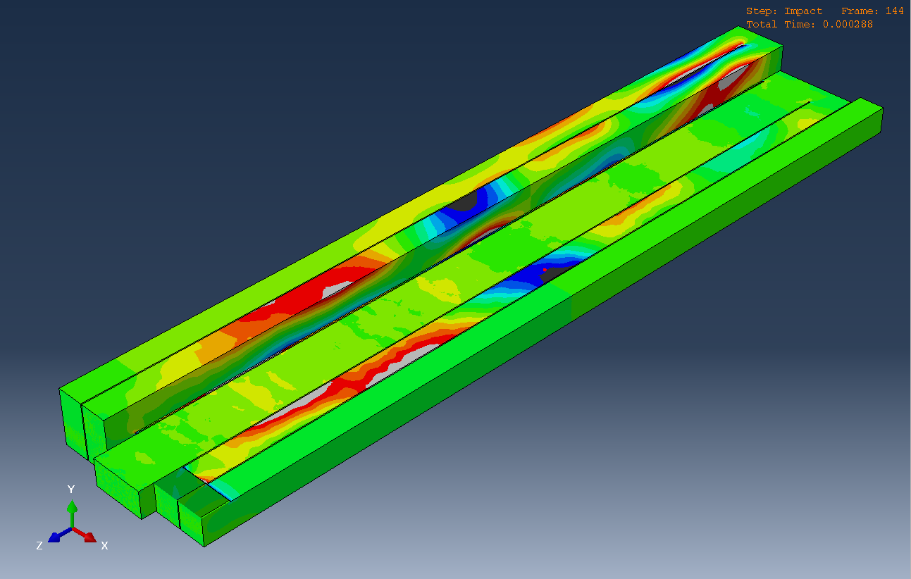
Section Cut
Section Cut
Point Gage
Fig. 26. Millipede bar with section cut view, removing Rod3 and Rod4 from view on one side. Gage region is shown in a red point outlined in a dashed white box. This frame is 288μs after initial impact, at the peak tension of Rod2.
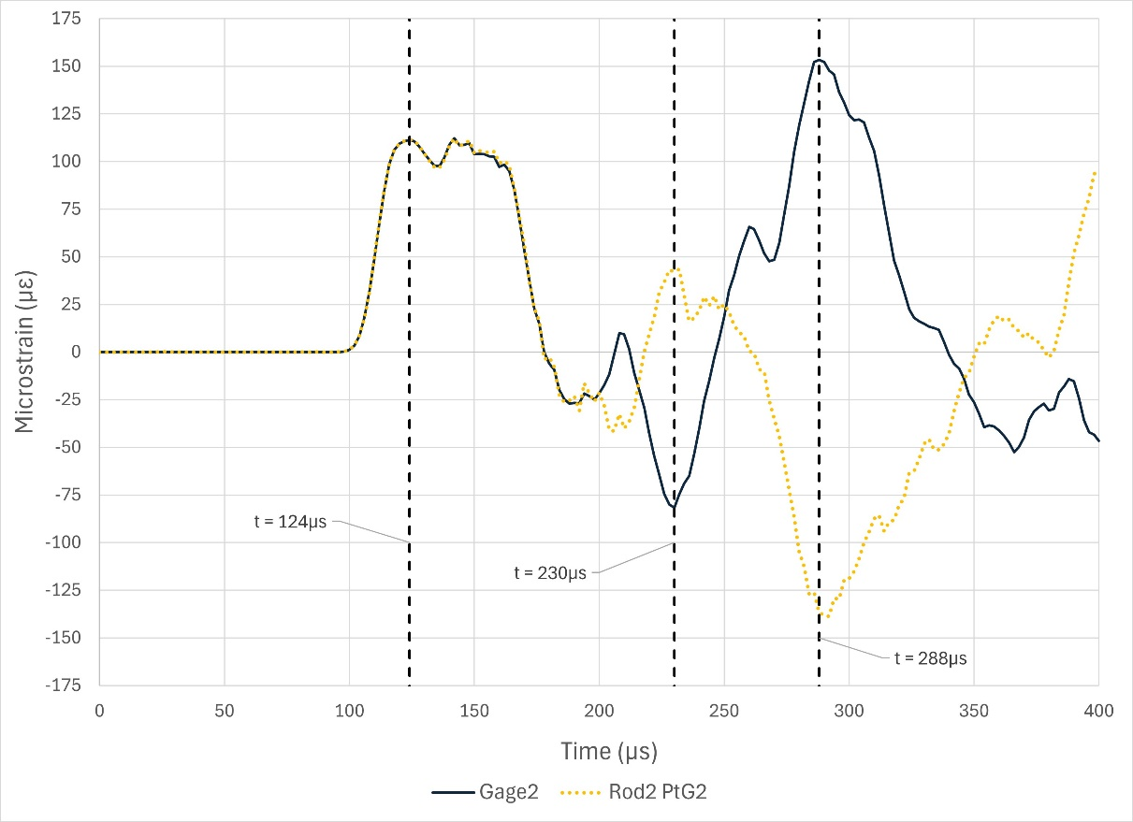
Fig. 27. Strain vs. time for short striker, unconstrained, measured at Gage2 and a Point Gage on a face opposite (180°) of Gage2.
Appendix A: Abaqus Results, No Boundary Conditions, Gages 1-5
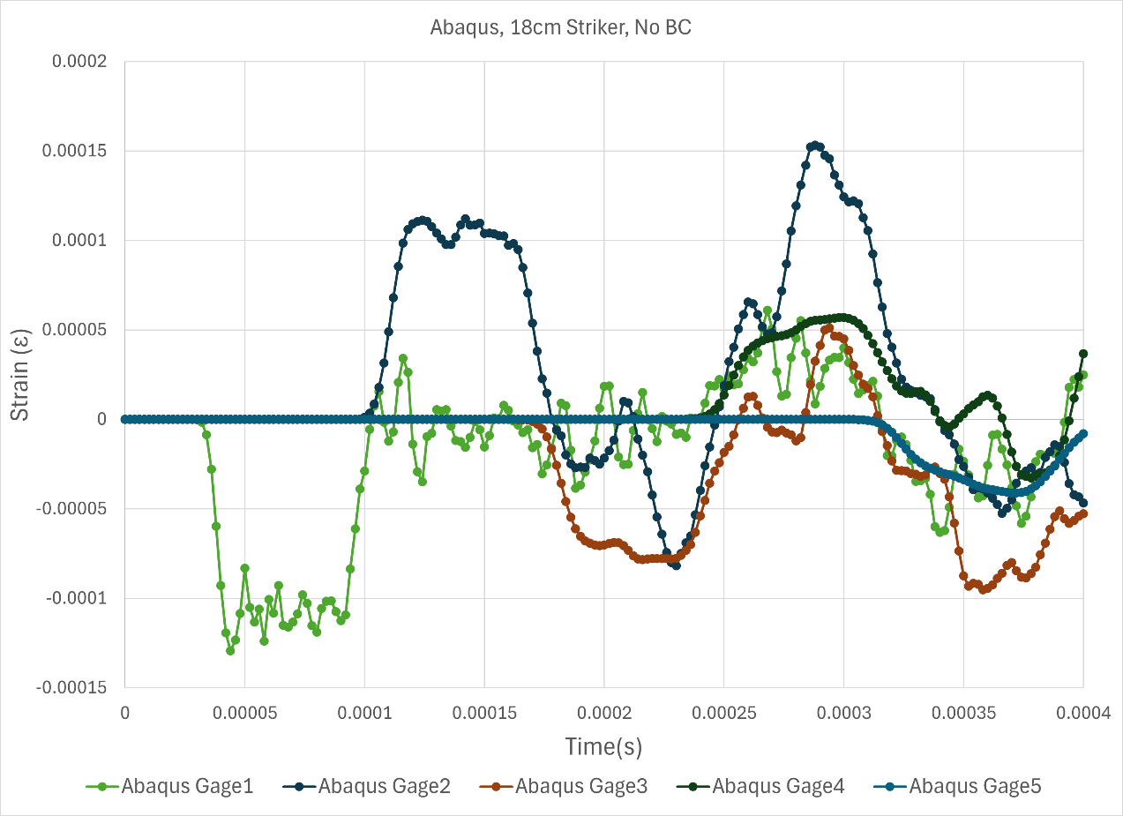
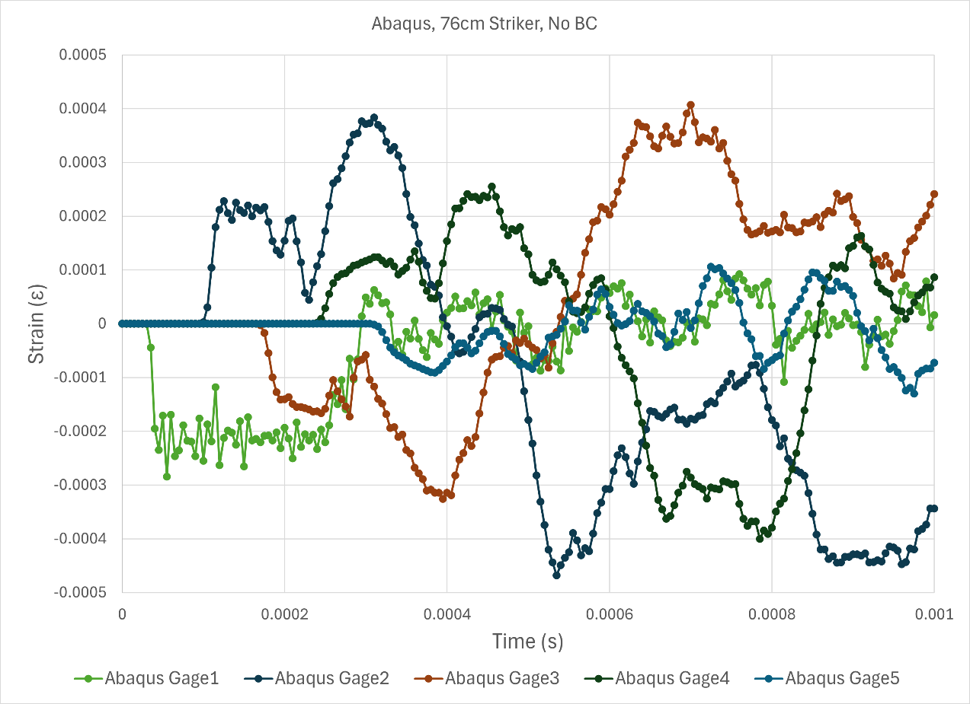
Appendix B: Additional Animations

[Object 6 – Animation: millipede bar axial stress, short striker, no BCs, deform scale x100]

[Object 7 – Animation: millipede bar axial stress, long striker, no BCs, deform scale x1]

Appendix C: Abaqus Results compared against Experimental Results, No Boundary Conditions, Gages 1-4, Long Striker, time cutoff 600μs
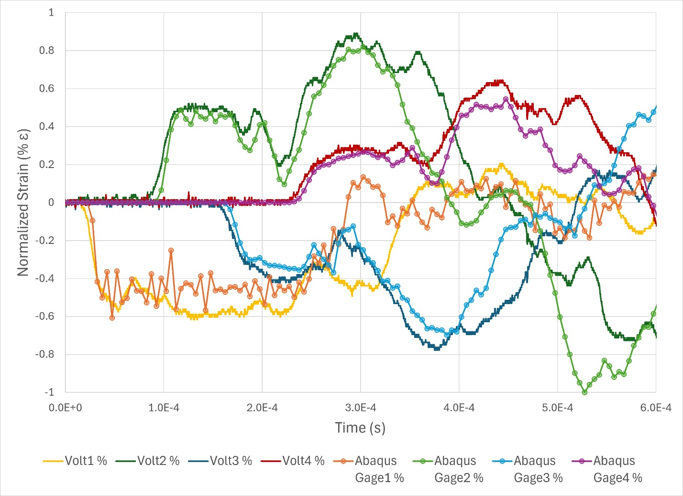

Bibliography
[1] | "Aluminum 6061-T6; 6061-T651," MatWeb, [Online]. Available: https://www.matweb.com/search/datasheet.aspx?MatGUID=b8d536e0b9b54bd7b69e4124d8f1d20a.
[2] | G. Subhash, A. Awasthi and D. Ghosh, Dynamic Response of Advanced Ceramics, 1st ed., Hoboken, New Jersey: Wiley-American Ceramic Society, 2021.
[3] | G. Subhash, J. Garcia-Suarez, A. Cheenady, S. Bavdekar, W. Whittington and J.-F. Molinari, "Stress wave propagation through a 180◦ bend junction in a square cross-sectional bar," International Journal of Engineering Science, vol. 180, no. 103748, 2022.
[4] | J. R. Asay, S. Urzendowski and A. H. Guenther, "Ultrasonic and Thermal Studies of Selected Plastics, Laminated Materials, and Metals," Air Force Weapons Laboratory, Albuquerque, New Mexico, 1968.
[5] | M. A. Meyers, Dynamic Behavior of Materials, New York, New York: John Wiley & Sons, Inc., 1994.
[6] | W. W. Chen and B. Song, Split Hopkinson (Kolsky) Bar: Design, Testing and Applications, Springer, 2011.

